

School of Electronics, Electrical Engineering & Computer Science

Queen’s University Belfast

CSC7052

A signed and completed cover sheet must accompany the submission of the Individual Software Development dissertation submitted for assessment.

Work submitted without a cover sheet will **NOT** be marked.

**Declaration of Academic Integrity**

Before signing the declaration below please check that the submission:

1. Has a full bibliography attached laid out according to the guidelines specified in the Student Project Handbook
2. Contains full acknowledgement of all secondary sources used (paper-based and electronic)
3. Does not exceed the specified page limit
4. Is clearly presented and proof-read
5. Is submitted on, or before, the specified or agreed due date. Late submissions will only be accepted in exceptional circumstances or where a deferment has been granted in advance.
6. Software and files are submitted on a memory stick.
7. Journal has been submitted.

**I declare that I have read both the University and the School of Electronics, Electrical Engineering and Computer Science guidelines on plagiarism - http://www.qub.ac.uk/schools/eeecs/Education/StudentStudyInformation/Plagiarism/ - and that the attached submission is my own original work. No part of it has been submitted for any other assignment and I have acknowledged in my notes and bibliography all written and electronic sources used.**

**I am aware of the disciplinary consequences of failing to abide and follow the School and Queen’s University Regulations on Plagiarism.**

|  |  |  |  |
| --- | --- | --- | --- |
| **Name: (BLOCK CAPITALS)** | **DEARBHÁIL RICE** | | |
| **Student Number:** | **40248863** | | |
|  |  |  |  |
| *Student’s signature* | D.Rice | *Date of submission* | 23/10/18 |

Contents

1. **Introduction**
2. **Overview of Functionality and Design of the Database**

2.1 Individual ER Diagram

2.2 Primary and Foreign Keys

2.3 Data Types

**3.**  **Design Decisions**

**4. Normalisation**

4.1 First Normal Form

4.2 Second Normal Form

4.3 Third Normal Form

**5. Buisness intelligence**

**6. Improvements**

**7. Conclusion**

**8. Appendix**

8.1 Appendix : Viva Overview

1. **Introduction**

The aim of this project, report and subsequent VIVA was to develop a relational database system mirroring the EasyJet booking System (<https://www.easyjet.com/en/> ) with a focus on limiting data redundancy as per the first principle of data Normalisation.

EasyJet’s website is supported by a database, it is assumed for the purpose of this project, of relational design. Therefore, an Entity Relationship (ER) diagram was developed by the design team to model the assumed required data to be stored and relationships between this data. These assumptions where made based on an in-depth review of the EasyJet websites User Interface (UI) and the domain knowledge of the design team as previous service users/Customers.

Once the design team agreed the initial ER diagram it was used by team members as a basis to inform and developed their own Individual ER diagrams, and aid development of their individual relational database in MySQL as per the assignment specification.

This report documents the design and implementation decisions of the database developer Dearbháil Rice, hereinafter referred to as the Developer .

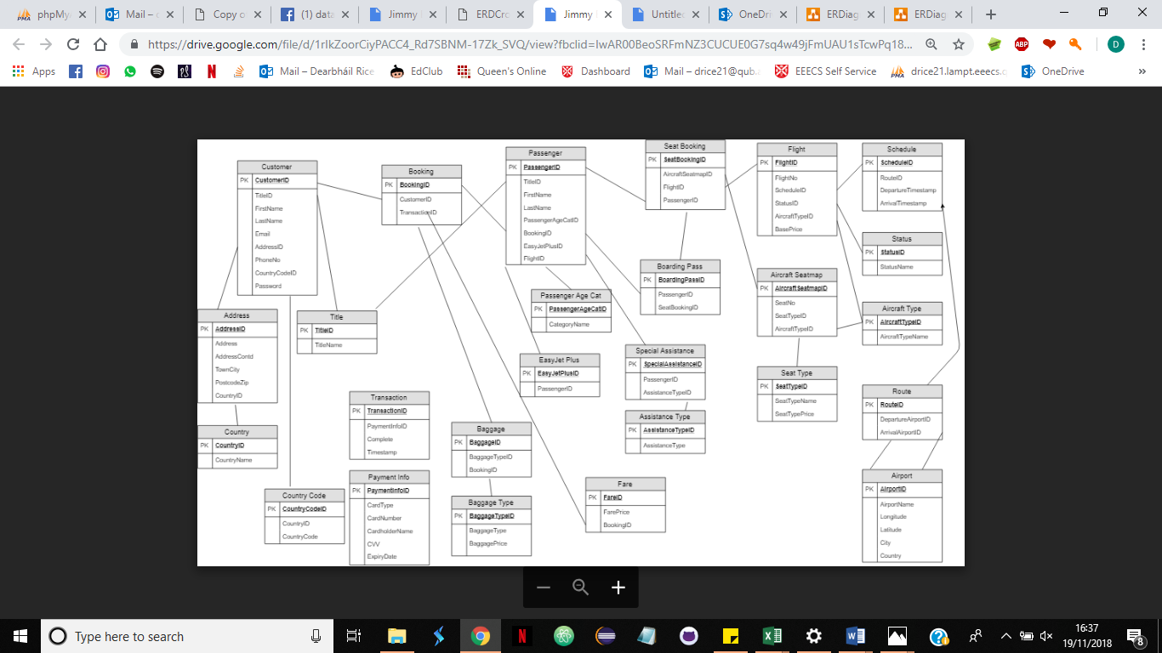Figure 1. Final Team ER Diagram Design

1. **Overview of Functionality and Design of the Database**

The developed database corresponds with the functionality of the user Interface (UI) on the EasyJet website. The database facilitates the storage of data for customer accounts, bookings, Passenger details as required by the client, information regarding flights and payments. It aims to aid the user interface in providing excellent customer experience, streamline the booking process for returning customers and assist the company in making future business decisions providing appropriate and accurate data for customers and flights. The Fina ER Diagram depicting the completed database in MySQL can be seen in Figure 3.

A Customer can create an account by providing their First name, Second name, Email address, Title, Address, Contact telephone number and a password which is AES encrypted . This customer ID may be linked to an easyJet plus account and multiple bookings.

Bookings contain at least one passenger with a seat on a flight. Passengers ages are stored to aid pricing and seat allocation. ( At this point it is assumed a Java program would be used to ensure where seats are assigned by a program that minors are sat with at least one adult to ensure all minors have appropriate supervision) Passenger may require assistance which can be recorded, within the assistance type table where the assistance types are encrypted to maintain the confidentiality of passengers. Passengers passport details may also be required for international flights therefore there is a facility to store passport information if required. It is noted that on the EasyJet parent website customers may select baggage and this baggage is associated with a booking not an individual passenger and is automatically added to both flights therefore baggage is a foreign key within bookings.

Flights within the database have an aircraft, route, schedule, seats and a status. Seats must be assigned to individual passengers, however with the construction of this data base passengers may be assigned to multiple seats within a booking to facilitate return bookings where passenger details are only entered once per booking. (Here it is assumed another java programme would check that a single passenger in a booking is not assigned to two seats).

EasyJet’s flight pricing system is quite complex, seats are sold in “buckets” at selected starting price points which rise in price . These bucket prices can be lowered to sell the few remaining seats of a bucket therefore allowing swifter progression to the next bucket at a higher price point. It is therefore assumed an algorithm is used where seats within each “bucket” are identified and prices are augmented according to business need. For this reason only, the base or cost price of each flight is stored within the database. An in-demand flight entity has been created to demonstrate that certain flights would carry an additional fee.

Baggage prices, seat type prices and VAT, which is associated to the route as VAT is dependent on departure and arrival destinations, are recorded within the data base in, these along with the calculated flight can be summed to produce the total booking price using a MySql query shown in Appendix 4. Step 8. They payment amount stored in the ezy_Transaction info table would be inserted from this sum query.

Transaction information and status are recoded in the database to allow the information to be passed to a program which would check to ensure the transaction has been completed successfully prior to issuing the customer with a booking reference and check-in facilities.

Payment information can be stored within the database, card numbers are protected with AES encryption . Note CSV numbers are not stored with the database in order to aid customers data protection. CSV numbers must be entered through the UI by the website user with each transaction attempt.

**2.1** **Individual ER Diagram**

The initial ER provided an over view for the proposed database design however it was not comprehensive or specific enough to implement into a relational database.

Figure 2. displays the developers Individual ER diagram design with additional entities such as Password , Payment information, check-in, Vat and further normalisation in the area such as seat identification and card expiry to reduce redundant data and erroneous input. The main divergence from the group ER diagram was how the passenger was related to other entities. In the group design the relation of a passenger to a booking is not fully developed, however a PassengerID is associated to a single seat booking on a flight therefore one person flying on a return journey(hereafter referred to as the traveller) would have two PassengerIDs. As EasyJet serves over 65million travellers per annuum it was felt creating two PassengerIDs for each traveller would use unnecessary volumes of memory. Therefore, in the individual design presented a passenger can have multiple seats in a booking. A java program is used to ensure multiple seats on the same flights are not assigned to one passenger. Also, by creating one passengerID per person traveling in a booking redundant data is further limited as the passenger is associated with only one set of passenger details and Passport details.

The diagram in Figure2. was used to develop the database in MYSQL the final ER diagram created from the MySQL Database can be viewed in Appendix1.4 of this document. Rather than developing a specific area of the database the developer opted to create a database the which could facilitate a customer from account creation to completing a booking, check-in and boarding pass creation. As such it was not possible to model some of the fine detail functionality of the website. This broader approach was taken to allow the developer to gain experience in database design and implementation with a wholistic approach.

2.2 Primary and Foreign Keys

Each entity within the database has a primary key. Primary keys within the database are all Ints(11), auto incremented (AI) and cannot be left Null to reduce repetition, ambiguity and give each entity a unique identifier to aid functionality of the database.

CustomerID within the ezy_Customers table of the database is a primary key used to uniquely identify each customer account holder. Creating a primary key for each customer allows customers of the same name, or date of birth etc to each hold different and uniquely identifiable accounts.

CustomerId is also a Foreign Key within multiple tables such as ezy_Booking and ezy_Address. Foreign keys allows the attributes of these tables to be linked and identified as belonging to one specific customer. By enforcing foreign key constraints the data’s normalisation can be improved, further reducing redundant data such as entering the customers full address in the booking table every time. By Adding constraints on the foreign key such as restrict and cascade on update or delete and foreign key checks the integrity of the data within the database can be maintained.

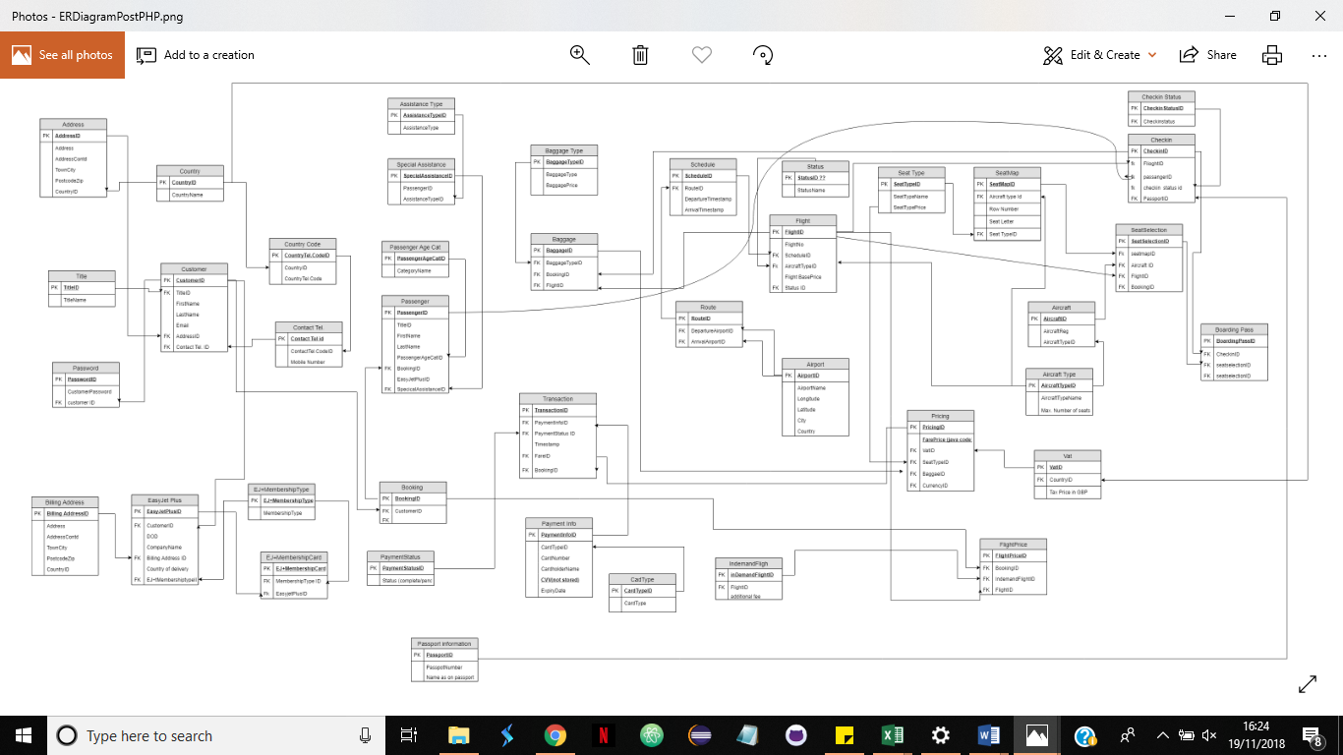

Figure 2. Developers ER diagram design

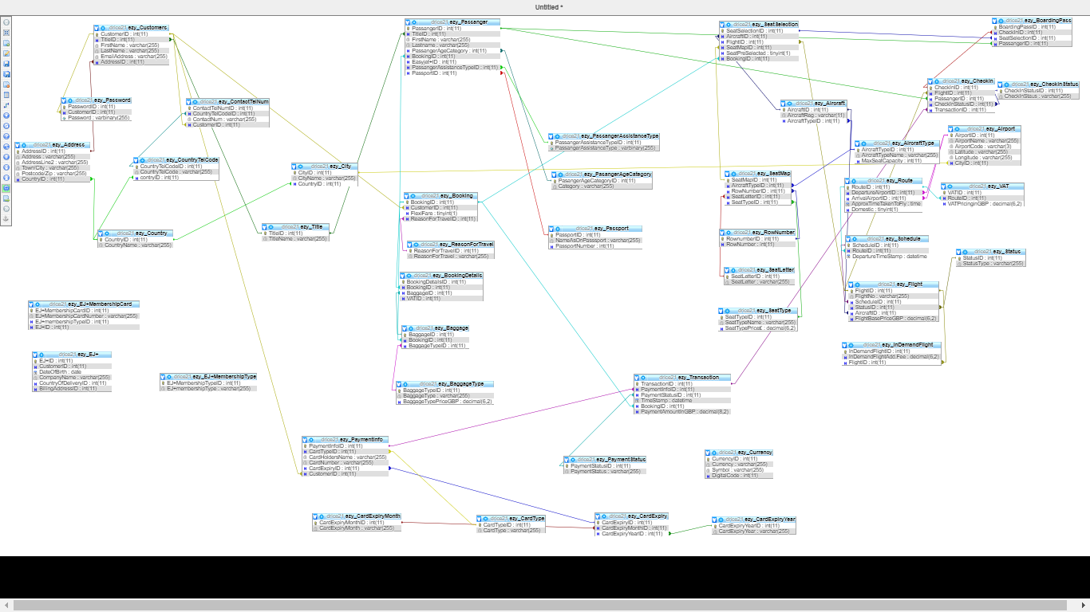

Figure 3. Entity Relationship Diagram From MySQL

* 1. **Data Types**

A comprehensive table showing the data type for each column within the database can be found in Appendix2.1. This table also indicates if a attribute is a Primary key or Foreign key within the database ( foreign keys are identified as MUL in Appendix 2.1 ). The bar chart in Figure 4. bellow depicts the range and frequency of the types of data used within the database. Ints are the most frequently used data type as a large proportion of the attributes where either a primary or foreign key to allow meaningful relationships to be created between the data. Int was the data type of choice for keys as it can be readily auto incremented and appeared the most suitable choice from the data types available. Figure 5. Diagrammatically represents this ratio of keyed to non-keyed attributes.

Varbinary data types where used to facilitate AES encryption within the required areas of the database. Such as passwords, Card numbers and Passenger Assistance requirements. Tiny Ints Indicate and record a Boolean field, for example flexi fare Is required a Boolean as passengers either have flexi fare or not. Seat preselection is also recorded as a Boolean (TinyInt) to allow this data to be passed to a java program where if a seat was not preselected (ie. 0) then the seat price will be deducted from the final pricing. Varchars where used throughout the database, key areas where to store phone numbers as often phone numbers start with a zero which would be lost if stored as an Int/BigInt. In order to store Airport codes which as standard are three characters in length the varchar length was limited to three to reduce instances of erroneous inputs. Decimals where used for monetary values such as flight base pricing and vat pricing. As EasyJet is a UK based company it is assumed that all pricing recorded in pounds sterling and converted to the appropriate currency for individual users using separate conversion software as currencies exchange rates vary regularly.

Figure 4. Bar chart showing the range and frequency of data types used

Figure 5. Pie chart depicting the relative proportion of primary keys and foreign keys compared with attributes without a key

1. **Design Decisions**

Design decisions where made in every area of the database design, development and implementation. Some elements of the design where revised during the implementation phase such as the decision to not include a fare or pricing table. This decision was significant within the design of this database it impacts on how each attribute which contributes to pricing is related to each other. To avoid repetition of data and data redundancy, where prices for specific booking are held in several places, it was decided that pricing should be calculated from a combination of a query and program as outlined in 2. Overview of Functionality and Design of the Database. The pricing query can be found in Appendix 4.Step 8 Payment information.

Developing the seat map format was one of the most significant design decisions of this project. The initial group design focused on individual aircraft types having independent seat maps. Following extensive planning and consideration it was decided by the developer that a master seat map with the aircraft type as a foreign key was more appropriate as it afforded a more simplistic but effective approach to seat selection and reduced memory usage versus creating a seat map for each individual flight.

Vat was included within the developed database and associated with route to improve pricing of flights accuracy and account for the variance in vat between countries and at times cities and airports.

Design decisions regarding security where not considered within the group design such as passwords which was held within the customer table with no encryption consideration given. The developer opted to AES encrypt passwords held within the database to improve data protection and protect customer data in turning assisting in maintaining and safeguarding the company reputation which is often severely damaged by customer information leaks .

1. **Normalisation**

4.1 First Normal Form

First normal Form (1NF) is achieved widely across the database. Many design decisions proceeding from the group ER diagram aimed to achieve a minimum of 1NF. Within the ezy_Customers table customers country codes where normalised out to a separate entity comprised of the country code and country ID.

4.2 Second Normal Form

The ezy_Customers table is an example where second normal form has been achieved as all non key attributes are dependent on the primary key and only the primary key( see Figure 6. Below )

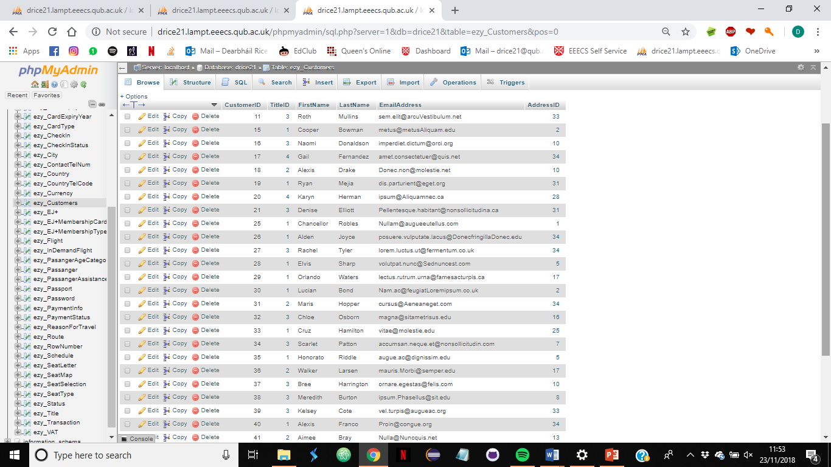

Figure 6. ezy_customer details example of second normal form

4.3 Third Normal Form

The ezy_Seatmap and ezy_CardType Tables are examples of where third normal form has been achieved within the database. All the attributes within the tables are dependant on the primary key and redundant data has been eliminated. (See Figure 7. bellow) The ezy_BookingDeatils and booking table both also adhere to third Normal form however it is felt further development is required in these areas.

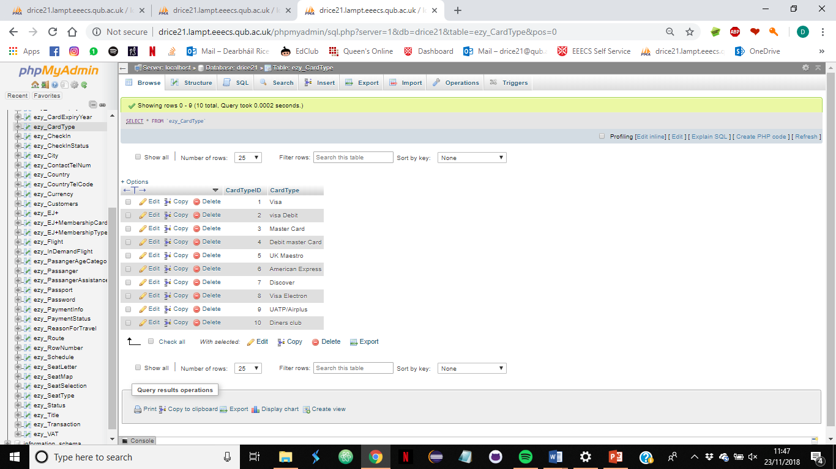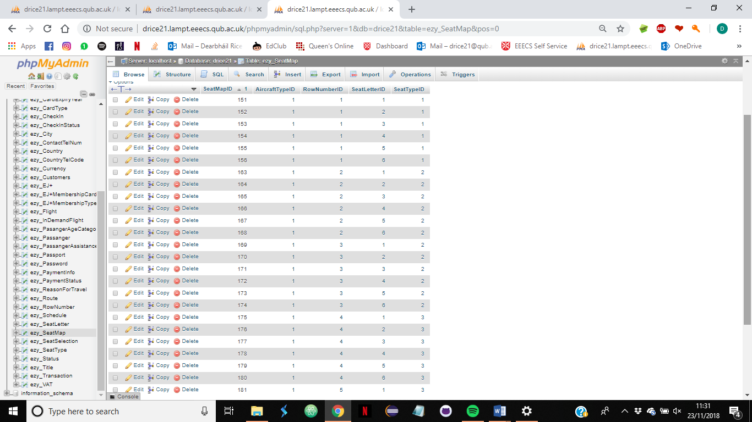Figure 7. excerpt of ezy_seatmap table and ezy_cardType table

1. **Business Intelligence**

Data stored within the database can be used to aid and inform business decisions. For example sales trends per annum and per month can be identified to determine if sales are rising or falling when compared with historical sales records. See appendix 3.1 -3.3 to view returned MYSQL data.

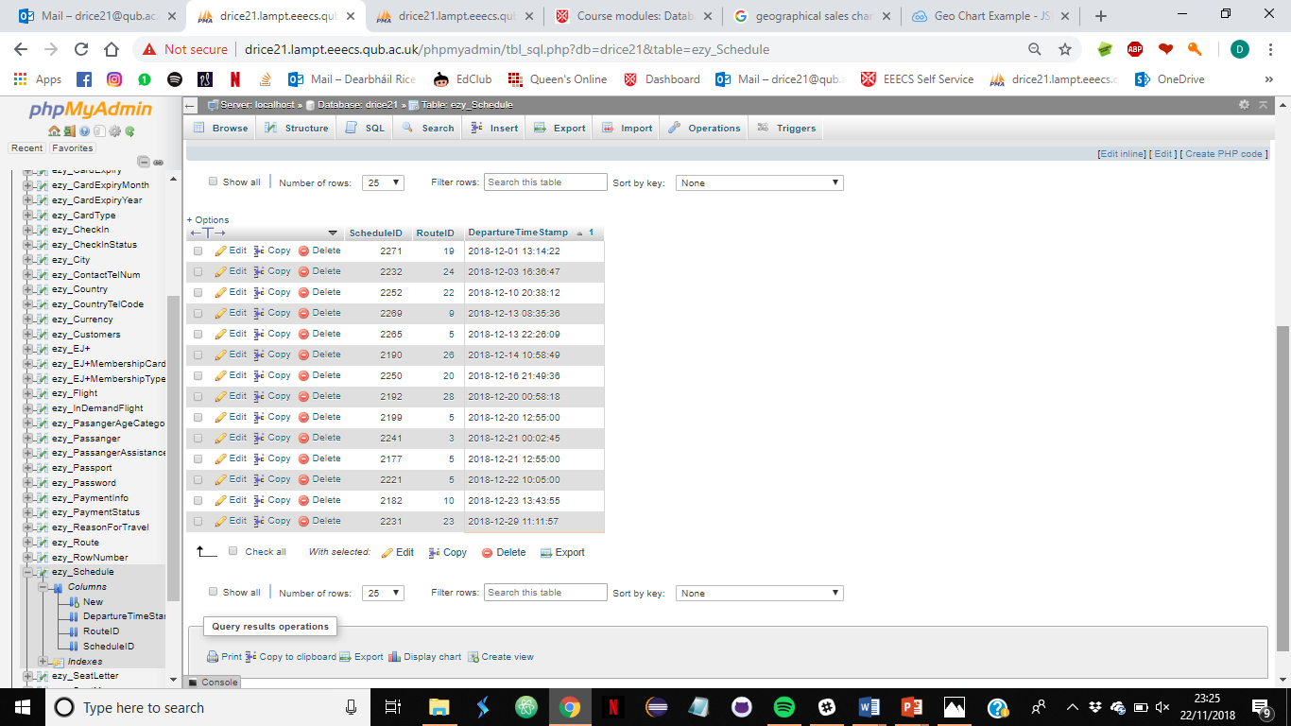

Figure . Monthly Flight MySQL Results

Figure . Annual flights MYSQL Results

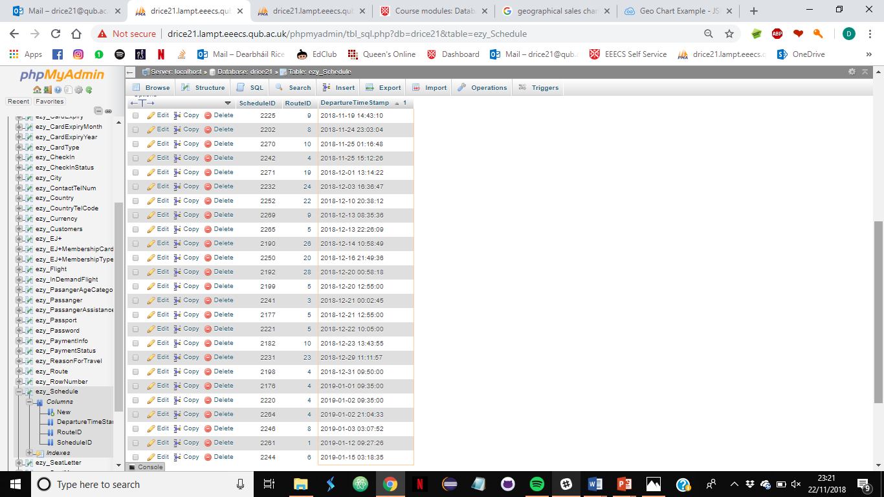

Figure . Graph showing Flight sales per month per annum where 2017 is represented by the line and 2018 by the bars.

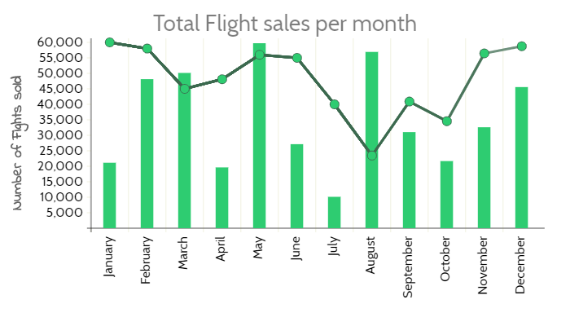

The data can also be used to determine where most and least passengers are flying from this may help to aid the business to decide where more routes my be feasible or where is least profitable to operate from.

Figure . Geo Chart depicting flight sales in 2018 per country.

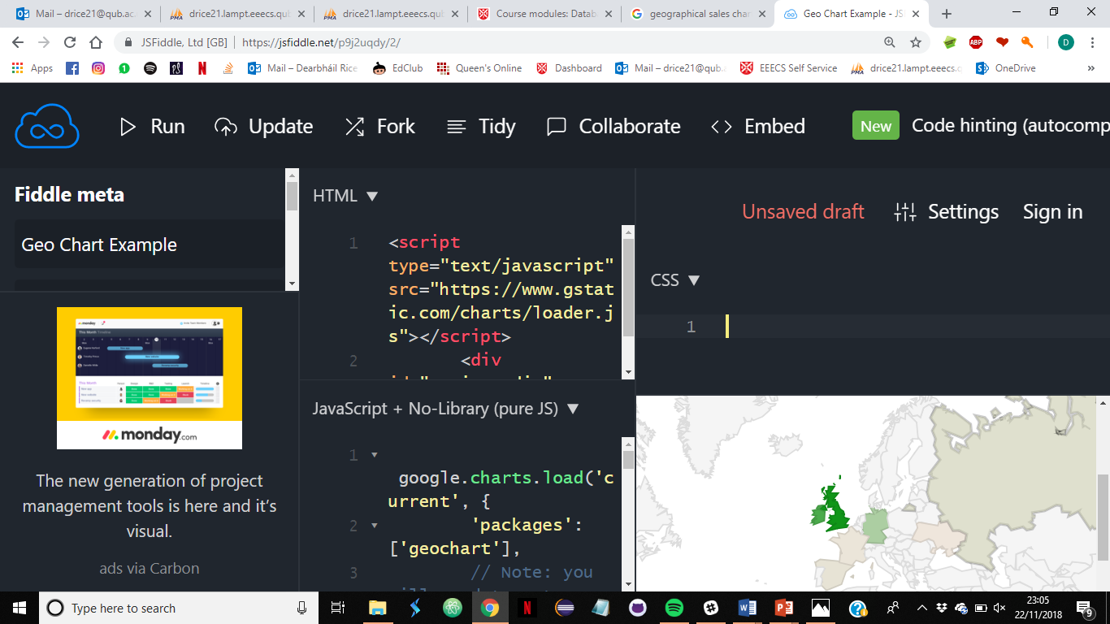

MySQL Queries and results can be found in appendix 3.5

1. **Improvements**

The database has been developed by an inexperienced designer and as such has many areas that could be improved a few areas where improvements could be made are outlined below:

* Within the data base it is felt that the seat selection area of the database could be improved by allowing seats to be allocated at time of check-in where seats where not specifically preselected. It was not possible to further develop this feature within the time constraints of the project.
* A time zone entity which would be used to calculate the arrival and departure times as per the corresponding destinations time zone would improve the functionality and ultimately UI user experience of this website.
* The booking details entity could be further utilised within the database to improve implementation of second normal form across the database reducing redundant data within tables and better consolidating booking data in a single table aiding pricing.
* The data base has no facility to easily count seats remaining on each flight this function may aid customer bookings as a program could display number of seats remaining when the number of sets available on a particular flight falls below approximately 15.
* Roll back functions may improve the database integrity with regards to the transactions if all components are not successfully completed none shall be completed.
* The passport Number should also be AES encrypted within the database
* The check-in and boarding pass functions are under developed due to time constraints, to improve data normalisation check-In Id should be associated with the BookingDetailsID and possibly passengerID at present they are of poor design and create redundant data with a high possibility for errors. It may be possible to create the boarding pass using a query rather than creating a table. However with improvements made to seat selection to allow for allocation of seat at time of check-in the boarding pass may require a foreign key constrain with seatselectionID. At present the information required to create a boarding pass can be selected using a MySQL query (see appendix 4. Step 10. Boarding pass)
* Encryption throughout the database could be improved by using AES encrypt 256 over the standard AES encrypt 128 which is used throughout the database.

1. **Conclusion**

The database over all is functional as evidenced by the full Booking process from account creation to Boarding pass depicted in Appendix 4.

There are areas, as identified above but not limited to same , for improvement. The database appears to meet the requirements laid out in the introduction and appears to contain sufficient dummy data to aptly display same.

1. **Appendix**

Appendix 1. Entity Relationship Diagrams

* 1. Identification of entities

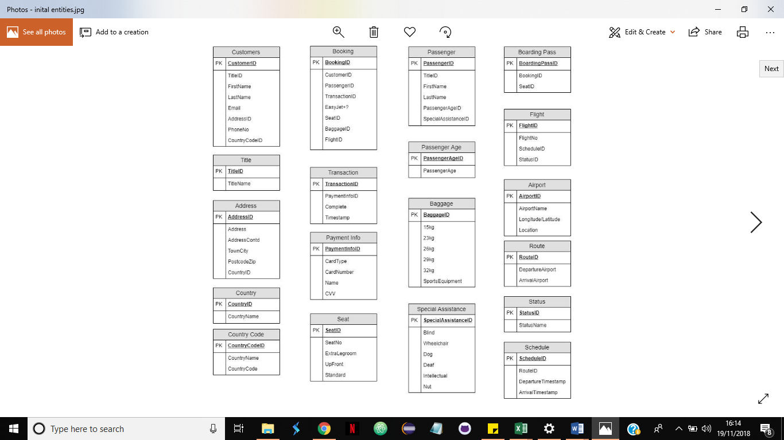

* 1. ER diagram with Individual Modifications version 1

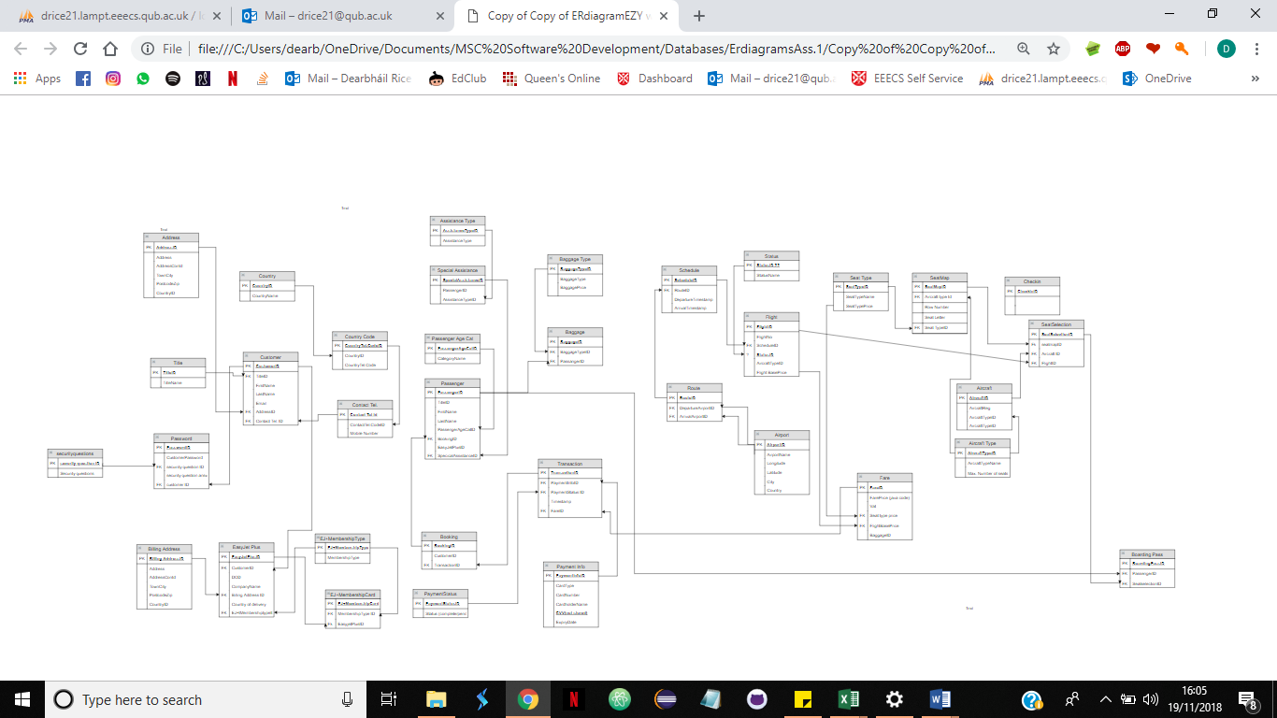

Appendix 2.1 Table showing data types and keys for all columns in the database

|  |  |  |  |  |  |  |
| --- | --- | --- | --- | --- | --- | --- |
| **TABLE_NAME COLUMN_NAME IS_NULLABLE DATA_TYPE COLUMN_TYPE COLUMN_KEY EXTRA** | | | | | | |
| ezy_Address | AddressID | NO | int | int(11) | PRI | AI |
| ezy_Address | Address | NO | varchar | varchar(255) |  |  |
| ezy_Address | AddressLine2 | YES | varchar | varchar(255) |  |  |
| ezy_Address | Town/City | NO | varchar | varchar(255) |  |  |
| ezy_Address | Postcode/Zip | NO | varchar | varchar(255) |  |  |
| ezy_Address | CountryID | YES | int | int(11) | MUL |  |
| ezy_Aircraft | AircraftID | NO | int | int(11) | PRI | AI |
| ezy_Aircraft | AircraftReg | NO | varchar | varchar(11) |  |  |
| ezy_Aircraft | AircraftTypeID | YES | int | int(11) | MUL |  |
| ezy_AircraftType | AircraftTypeID | NO | int | int(11) | PRI | AI |
| ezy_AircraftType | AircraftTypeName | NO | varchar | varchar(255) |  |  |
| ezy_AircraftType | MaxSeatCapacity | YES | int | int(11) |  |  |
| ezy_Airport | AirportID | NO | int | int(11) | PRI | AI |
| ezy_Airport | AirportName | NO | varchar | varchar(255) |  |  |
| ezy_Airport | AirportCode | NO | varchar | varchar(3) |  |  |
| ezy_Airport | Latitude | NO | varchar | varchar(255) |  |  |
| ezy_Airport | Longitude | NO | varchar | varchar(255) |  |  |
| ezy_Airport | CityID | NO | int | int(11) | MUL |  |
| ezy_Baggage | BaggageID | NO | int | int(11) | PRI | AI |
| ezy_Baggage | BookingID | NO | int | int(11) | MUL |  |
| ezy_Baggage | BaggageTypeID | NO | int | int(11) | MUL |  |
| ezy_BaggageType | BaggageTypeID | NO | int | int(11) | PRI | AI |
| ezy_BaggageType | BaggageType | NO | varchar | varchar(255) |  |  |
| ezy_BaggageType | BaggageTypePriceGBP | NO | decimal | decimal(6,2) |  |  |
| ezy_BoardingPass | BoardingPassID | NO | int | int(11) | PRI | AI |
| ezy_BoardingPass | CheckInID | NO | int | int(11) | MUL |  |
| ezy_BoardingPass | SeatSelectionID | NO | int | int(11) | MUL |  |
| ezy_BoardingPass | PassangerID | NO | int | int(11) | MUL |  |
| ezy_Booking | BookingID | NO | int | int(11) | PRI | AI |
| ezy_Booking | CustomerID | NO | int | int(11) | MUL |  |
| ezy_BookingDetails | BookingDetailsID | NO | int | int(11) | PRI | AI |
| ezy_BookingDetails | BookingID | NO | int | int(11) | MUL |  |
| ezy_BookingDetails | FlexiFare | NO | tinyint | tinyint(1) |  |  |
| ezy_BookingDetails | ReasonForTravelID | NO | int | int(11) | MUL |  |
| ezy_CardExpiry | CardExpiryID | NO | int | int(11) | PRI | AI |
| ezy_CardExpiry | CardExpiryMonthID | NO | int | int(11) | MUL |  |
| ezy_CardExpiry | CardExpiryYearID | NO | int | int(11) | MUL |  |
| ezy_CardExpiryMonth | CardExpiryMonthID | NO | int | int(11) | PRI | AI |
| ezy_CardExpiryMonth | CardExpiryMonth | NO | varchar | varchar(255) |  |  |
| ezy_CardExpiryYear | CardExpiryYearID | NO | int | int(11) | PRI | AI |
| ezy_CardExpiryYear | CardExpiryYear | NO | varchar | varchar(255) |  |  |
| ezy_CardType | CardTypeID | NO | int | int(11) | PRI | AI |
| ezy_CardType | CardType | NO | varchar | varchar(255) |  |  |
| ezy_CheckIn | CheckInID | NO | int | int(11) | PRI | AI |
| ezy_CheckIn | FlightID | NO | int | int(11) | MUL |  |
| ezy_CheckIn | PassangerID | NO | int | int(11) | MUL |  |
| ezy_CheckIn | CheckInStatusID | NO | int | int(11) | MUL |  |
| ezy_CheckIn | TransactionID | NO | int | int(11) | MUL |  |
| ezy_CheckInStatus | CheckInStatusID | NO | int | int(11) | PRI | AI |
| ezy_CheckInStatus | CheckInStaus | NO | varchar | varchar(255) |  |  |
| ezy_City | CityID | NO | int | int(11) | PRI | AI |
| ezy_City | CityName | NO | varchar | varchar(255) |  |  |
| ezy_City | CountryID | YES | int | int(11) | MUL |  |
| ezy_ContactTelNum | ContactTelNumID | NO | int | int(11) | PRI | AI |
| ezy_ContactTelNum | CountryTelCodeID | NO | int | int(11) | MUL |  |
| ezy_ContactTelNum | ContactNum | NO | varchar | varchar(255) |  |  |
| ezy_ContactTelNum | CustomerID | NO | int | int(11) | MUL |  |
| ezy_Country | CountryID | NO | int | int(11) | PRI | AI |
| ezy_Country | CountryName | NO | varchar | varchar(255) |  |  |
| ezy_CountryTelCode | CountryTelCodeID | NO | int | int(11) | PRI | AI |
| ezy_CountryTelCode | CountryTelCode | NO | varchar | varchar(255) |  |  |
| ezy_CountryTelCode | contryID | NO | int | int(11) | MUL |  |
| ezy_Currency | CurrencyID | NO | int | int(11) | PRI | AI |
| ezy_Currency | Currency | NO | varchar | varchar(255) |  |  |
| ezy_Currency | Symbol | YES | varchar | varchar(255) |  |  |
| ezy_Currency | DigitalCode | YES | int | int(11) |  |  |
| ezy_Customers | CustomerID | NO | int | int(11) | PRI | AI |
| ezy_Customers | TitleID | YES | int | int(11) | MUL |  |
| ezy_Customers | FirstName | NO | varchar | varchar(255) |  |  |
| ezy_Customers | LastName | NO | varchar | varchar(255) |  |  |
| ezy_Customers | EmailAddress | NO | varchar | varchar(255) |  |  |
| ezy_Customers | AddressID | YES | int | int(11) | MUL |  |
| ezy_EJ+ | EJ+ID | NO | int | int(11) | PRI | AI |
| ezy_EJ+ | CustomerID | NO | int | int(11) | MUL |  |
| ezy_EJ+ | DateOfBirth | NO | date | date |  |  |
| ezy_EJ+ | CompanyName | YES | varchar | varchar(255) |  |  |
| ezy_EJ+ | CountryOfDeliveryID | NO | int | int(11) | MUL |  |
| ezy_EJ+ | BillingAddressID | NO | int | int(11) | MUL |  |
| ezy_EJ+MembershipCard | EJ+MembershipCardID | NO | int | int(11) | PRI | AI |
| ezy_EJ+MembershipCard | EJ+MembershipCardNumber | NO | varchar | varchar(255) |  |  |
| ezy_EJ+MembershipCard | EJ+membershipTypeID | NO | int | int(11) | MUL |  |
| ezy_EJ+MembershipCard | EJ+ID | NO | int | int(11) | MUL |  |
| ezy_EJ+MembershipType | EJ+MembershipTypeID | NO | int | int(11) | PRI | AI |
| ezy_EJ+MembershipType | EJ+membershipType | NO | varchar | varchar(255) |  |  |
| ezy_Flight | FlightID | NO | int | int(11) | PRI | AI |
| ezy_Flight | FlightNo | NO | varchar | varchar(255) |  |  |
| ezy_Flight | ScheduleID | NO | int | int(11) | MUL |  |
| ezy_Flight | StatusID | NO | int | int(11) | MUL |  |
| ezy_Flight | AircraftID | NO | int | int(11) | MUL |  |
| ezy_Flight | FlightBasePriceGBP | NO | decimal | decimal(6,2) |  |  |
| ezy_InDemandFlight | InDemandFlightID | NO | int | int(11) | PRI | AI |
| ezy_InDemandFlight | InDemandFlightAddFee | NO | decimal | decimal(6,2) |  |  |
| ezy_InDemandFlight | FlightID | NO | int | int(11) | MUL |  |
| ezy_PasangerAgeCategory | PasangerAgeCategoryID | NO | int | int(11) | PRI | AI |
| ezy_PasangerAgeCategory | Category | NO | varchar | varchar(255) |  |  |
| ezy_Passanger | PassangerID | NO | int | int(11) | PRI | AI |
| ezy_Passanger | TitleID | NO | int | int(11) | MUL |  |
| ezy_Passanger | FirstName | NO | varchar | varchar(255) |  |  |
| ezy_Passanger | Lastname | NO | varchar | varchar(255) |  |  |
| ezy_Passanger | PassangerAgeCategory | NO | int | int(11) | MUL |  |
| TABLE_NAME | COLUMN_NAME | IS_NULLABLE | DATA_TYPE | COLUMN_TYPE | COLUMN_KEY | EXTRA |
| ezy_Passanger | BookingID | NO | int | int(11) | MUL |  |
| ezy_Passanger | Easyjet+ID | YES | int | int(11) | MUL |  |
| ezy_Passanger | PassangerAssistanceTypeID | YES | int | int(11) | MUL |  |
| ezy_Passanger | PassportID | YES | int | int(11) | MUL |  |
| ezy_PassangerAssistanceType | PassangerAssistanceTypeID | NO | int | int(11) | PRI | AI |
| ezy_PassangerAssistanceType | PassangerAssistanceType | NO | varbinary | varbinary(255) |  |  |
| ezy_Passport | PassportID | NO | int | int(11) | PRI | AI |
| ezy_Passport | NameAsOnPasssport | NO | varchar | varchar(255) |  |  |
| ezy_Passport | PassportNumber | NO | int | int(11) |  |  |
| ezy_Password | PasswordID | NO | int | int(11) | PRI | AI |
| ezy_Password | CustomerID | NO | int | int(11) | MUL |  |
| ezy_Password | Password | NO | varbinary | varbinary(255) |  |  |
| ezy_PaymentInfo | PaymentInfoID | NO | int | int(11) | PRI | AI |
| ezy_PaymentInfo | CardTypeID | NO | int | int(11) | MUL |  |
| ezy_PaymentInfo | CardHoldersName | NO | varchar | varchar(255) |  |  |
| ezy_PaymentInfo | CardNumber | NO | varbinary | varbinary(255) |  |  |
| ezy_PaymentInfo | CardExpiryID | NO | int | int(11) | MUL |  |
| ezy_PaymentInfo | CustomerID | NO | int | int(11) | MUL |  |
| ezy_PaymentStatus | PaymentStatusID | NO | int | int(11) | PRI | AI |
| ezy_PaymentStatus | PaymentStatus | NO | varchar | varchar(255) |  |  |
| ezy_ReasonForTravel | ReasonForTravelID | NO | int | int(11) | PRI | AI |
| ezy_ReasonForTravel | ReasonForTravel | NO | varchar | varchar(255) |  |  |
| ezy_Route | RouteID | NO | int | int(11) | PRI | AI |
| ezy_Route | DepartureAirportID | NO | int | int(11) | MUL |  |
| ezy_Route | ArrivalAirportID | NO | int | int(11) | MUL |  |
| ezy_Route | ApproxTimeTakenToFly | NO | time | time |  |  |
| ezy_Route | Domestic | NO | tinyint | tinyint(1) |  |  |
| ezy_RowNumber | RownumberID | NO | int | int(11) | PRI | AI |
| ezy_RowNumber | RowNumber | NO | int | int(11) |  |  |
| ezy_Schedule | ScheduleID | NO | int | int(11) | PRI | AI |
| ezy_Schedule | RouteID | NO | int | int(11) | MUL |  |
| ezy_Schedule | DepartureTimeStamp | NO | datetime | datetime |  |  |
| ezy_SeatLetter | SeatLetterID | NO | int | int(11) | PRI | AI |
| ezy_SeatLetter | SeatLetter | NO | varchar | varchar(255) |  |  |
| ezy_SeatMap | SeatMapID | NO | int | int(11) | PRI | AI |
| ezy_SeatMap | AircraftTypeID | NO | int | int(11) | MUL |  |
| ezy_SeatMap | RowNumberID | NO | int | int(11) | MUL |  |
| ezy_SeatMap | SeatLetterID | NO | int | int(11) | MUL |  |
| ezy_SeatMap | SeatTypeID | NO | int | int(11) | MUL |  |
| ezy_SeatSelection | SeatSelectionID | NO | int | int(11) | PRI | AI |
| ezy_SeatSelection | FlightID | NO | int | int(11) | MUL |  |
| ezy_SeatSelection | SeatMapID | YES | int | int(11) | MUL |  |
| ezy_SeatSelection | SeatPreSelected | NO | tinyint | tinyint(1) |  |  |
| ezy_SeatSelection | BookingID | NO | int | int(11) | MUL |  |
| ezy_SeatType | SeatTypeID | NO | int | int(11) | PRI | AI |
| ezy_SeatType | SeatTypeName | NO | varchar | varchar(255) |  |  |
| ezy_SeatType | SeatTypePrice£ | NO | decimal | decimal(6,2) |  |  |
| ezy_Status | StatusID | NO | int | int(11) | PRI | AI |
| ezy_Status | StatusType | NO | varchar | varchar(255) |  |  |
| ezy_Title | TitleID | NO | int | int(11) | PRI | AI |
| ezy_Title | TitleName | NO | varchar | varchar(255) |  |  |
| ezy_Transaction | TransactionID | NO | int | int(11) | PRI | AI |
| ezy_Transaction | PaymentInfoID | NO | int | int(11) | MUL |  |
| ezy_Transaction | PaymentStatusID | NO | int | int(11) | MUL |  |
| ezy_Transaction | TimeStamp | NO | datetime | datetime |  |  |
| ezy_Transaction | BookingID | NO | int | int(11) | MUL |  |
| ezy_Transaction | PaymentAmountInGBP | NO | decimal | decimal(8,2) |  |  |
| ezy_VAT | VATID | NO | int | int(11) | PRI | AI |
| ezy_VAT | RouteID | NO | int | int(11) | MUL |  |
| ezy_VAT | VATPricinginGBP | YES | decimal | decimal(6,2) |  |  |

Appendix 2.2 Table showing the count of distinct data types used

|  |  |
| --- | --- |
| **DATA_TYPE** | **Count of DATA_TYPE** |
| DATA_TYPE | 1 |
| date | 1 |
| datetime | 2 |
| decimal | 6 |
| int | 105 |
| time | 1 |
| tinyint | 3 |
| varbinary | 3 |
| varchar | 39 |

Appendix 2.3 count of primary and froing keys from Table in Appendix 2.1

|  |  |
| --- | --- |
| **Key Type** | **Key Count** |
| Primary | 45 |
| Forign | 56 |
| Attributes without key | 60 |

**Appendix 3 Business Intelligence**

Appendix 3.1 Annual flights query

select* from ezy_Schedule

Where DepartureTimeStamp

BETWEEN '2018-01-01' And '2019-12-31'

ORDER BY `ezy_Schedule`.`DepartureTimeStamp` ASC

Appendix 3.2 Monthly Flight Query

select* from ezy_Schedule

Where DepartureTimeStamp

BETWEEN '2018-12-01' And '2018-12-31'

ORDER BY `ezy_Schedule`.`DepartureTimeStamp` ASC;

Appendix 3.3 The MySQL Query to retrieve annual data for seats selected for 2018:

select COUNT(ezy_SeatSelection.SeatSelectionID) from ezy_Schedule

INNER JOIN ezy_Flight

ON ezy_Flight.ScheduleID=ezy_Schedule.ScheduleID

Inner Join ezy_SeatSelection

On ezy_Flight.FlightID = ezy_SeatSelection.FlightID

Where DepartureTimeStamp

BETWEEN '2018-01-01' And '2019-12-31' ORDER BY `ezy_Schedule`.`DepartureTimeStamp` ASC;

Appendix 3.4 Displays total seats booked in a month

select COUNT(ezy_SeatSelection.SeatSelectionID) from ezy_Schedule

INNER JOIN ezy_Flight

ON ezy_Flight.ScheduleID=ezy_Schedule.ScheduleID

Inner Join ezy_SeatSelection

On ezy_Flight.FlightID = ezy_SeatSelection.FlightID

Where DepartureTimeStamp

BETWEEN '2018-12-01' And '2018-12-31'

ORDER BY `ezy_Schedule`.`DepartureTimeStamp` ASC;

Appendix 3.5 Query to identify and count number of seats on flights departing from each distinct country within a set time period (one Year)

select DISTINCT ezy_Country.CountryName, COUNT(ezy_SeatSelection.SeatSelectionID) from ezy_Schedule

INNER JOIN ezy_Flight

ON ezy_Flight.ScheduleID=ezy_Schedule.ScheduleID

Inner Join ezy_SeatSelection

On ezy_Flight.FlightID = ezy_SeatSelection.FlightID

INNER JOIN ezy_Route

On ezy_Route.RouteID=ezy_Schedule.RouteID

INNER JOIN ezy_Airport

ON ezy_Route.DepartureAirportID=ezy_Airport.AirportID

INNER Join ezy_City

ON ezy_Airport.CityID=ezy_City.CityID

INNER JOIN ezy_Country

ON ezy_City.CountryID=ezy_Country.CountryID

Where DepartureTimeStamp BETWEEN '2018-01-01' And '2019-12-31' ORDER BY `ezy_Schedule`.`DepartureTimeStamp` ASC;

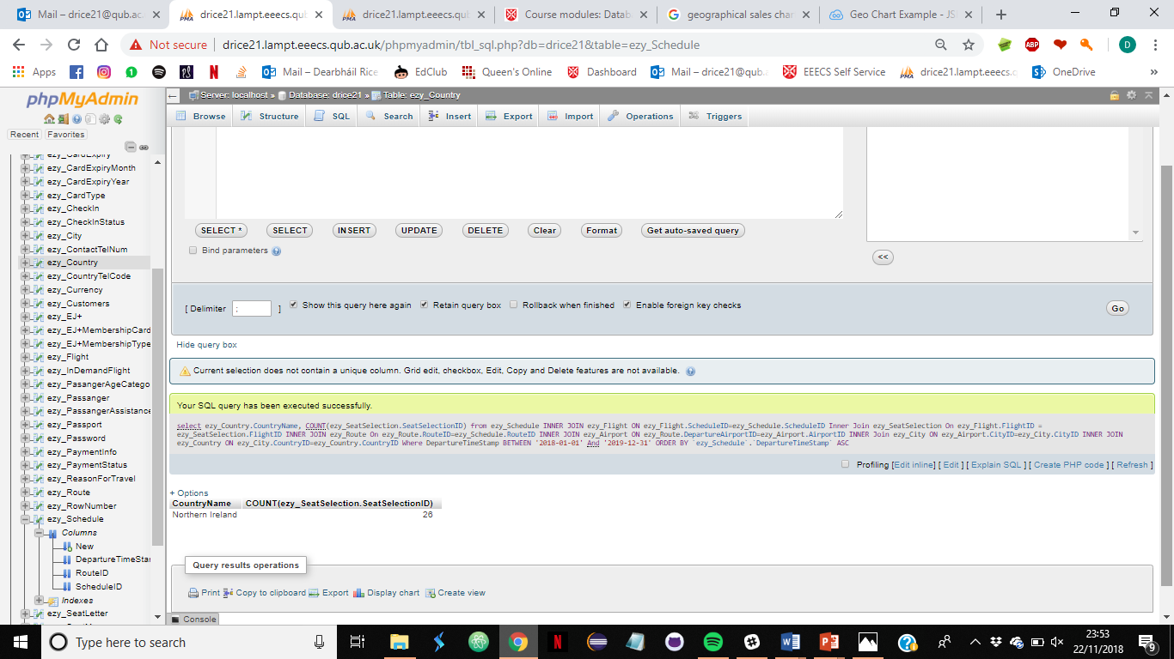

**8.1 Appendix VIVA Demonstration Overview**

**Appendix 4.**

**Booking scenario**

**Miss Harley Quinn wishes to travel from Amsterdam to Belfast return for Christmas and new years She requires one suitcase of 23kg. She wishes to select an "upfront seat". She also requires assistance as she has a nut allergy.**

**Step 1. Create a Customer Account**

* Data entry on EasyJet UI:

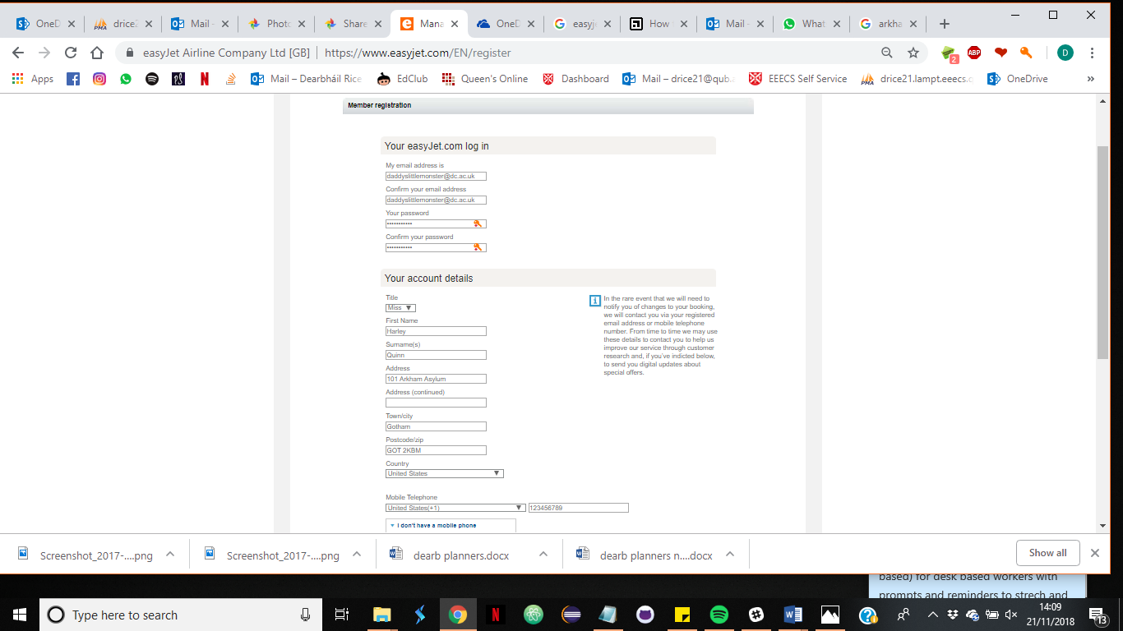

* 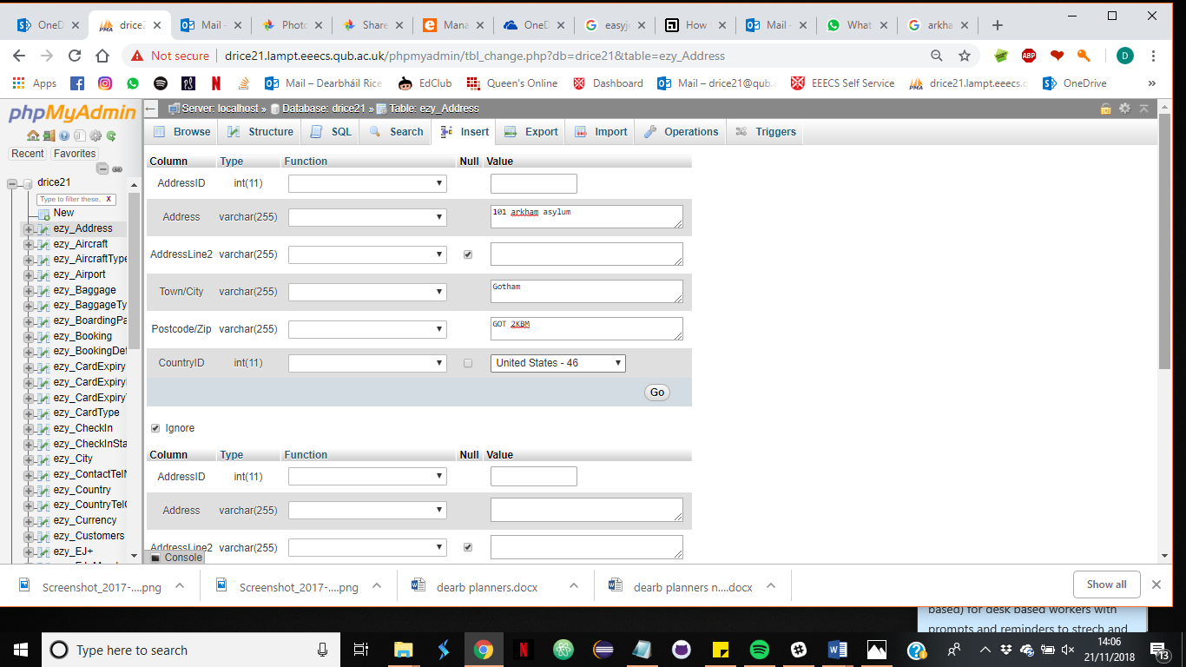Corresponding data entry on MySQL:

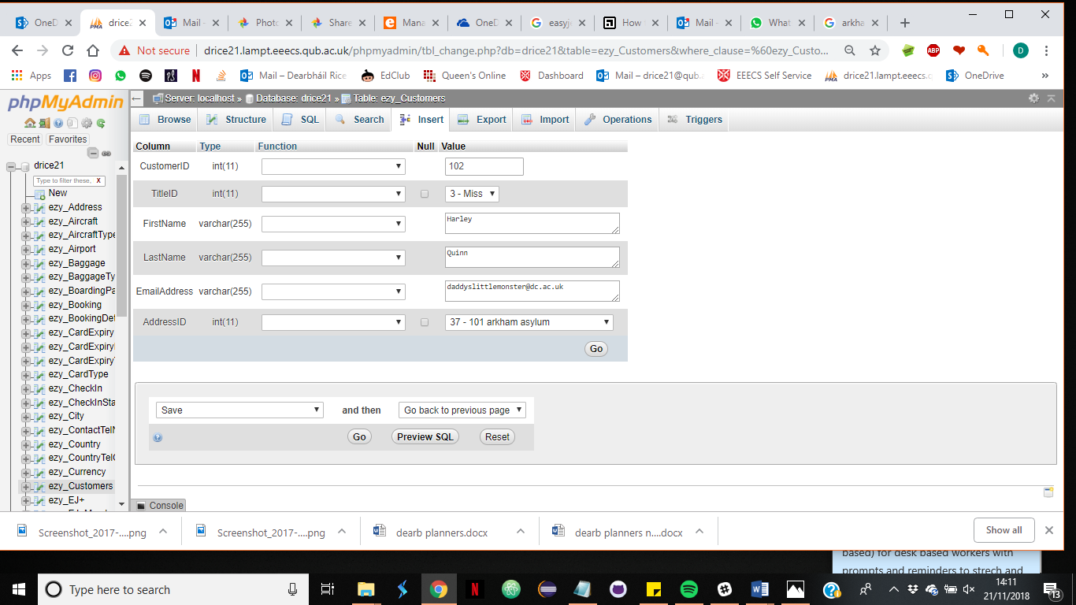

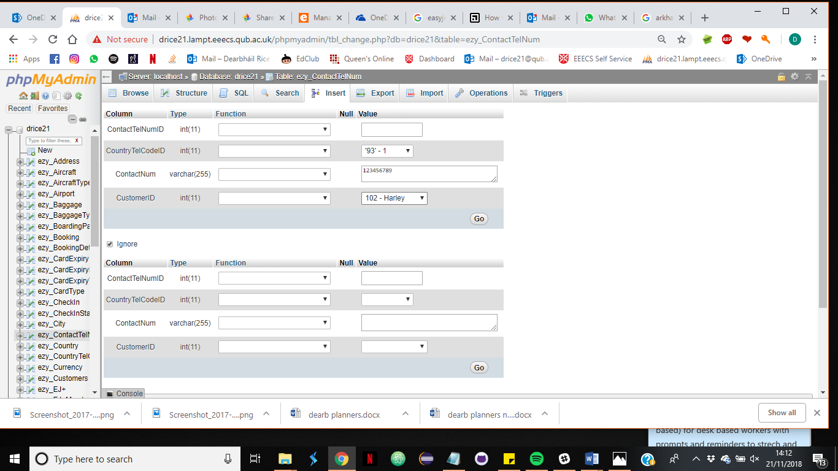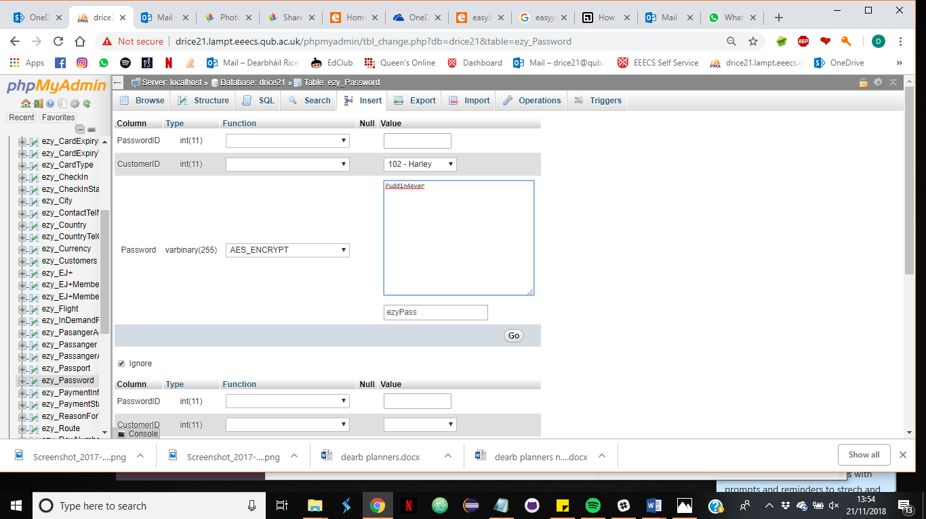

Bellow confirms the password has been successfully encrypted :

select * From ezy_Password where CustomerID=102;

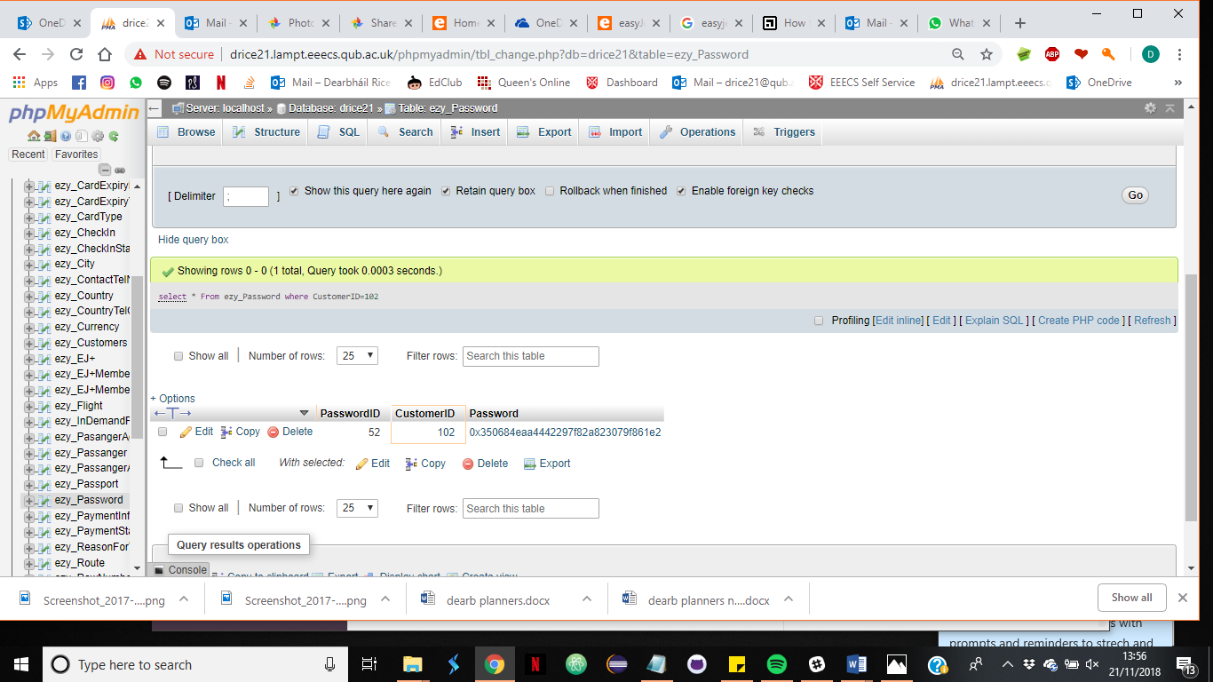

To decrypt the password:

SELECT customerID, AES_DECRYPT(Password, 'ezyPass') from ezy_Password

where CustomerID=102;

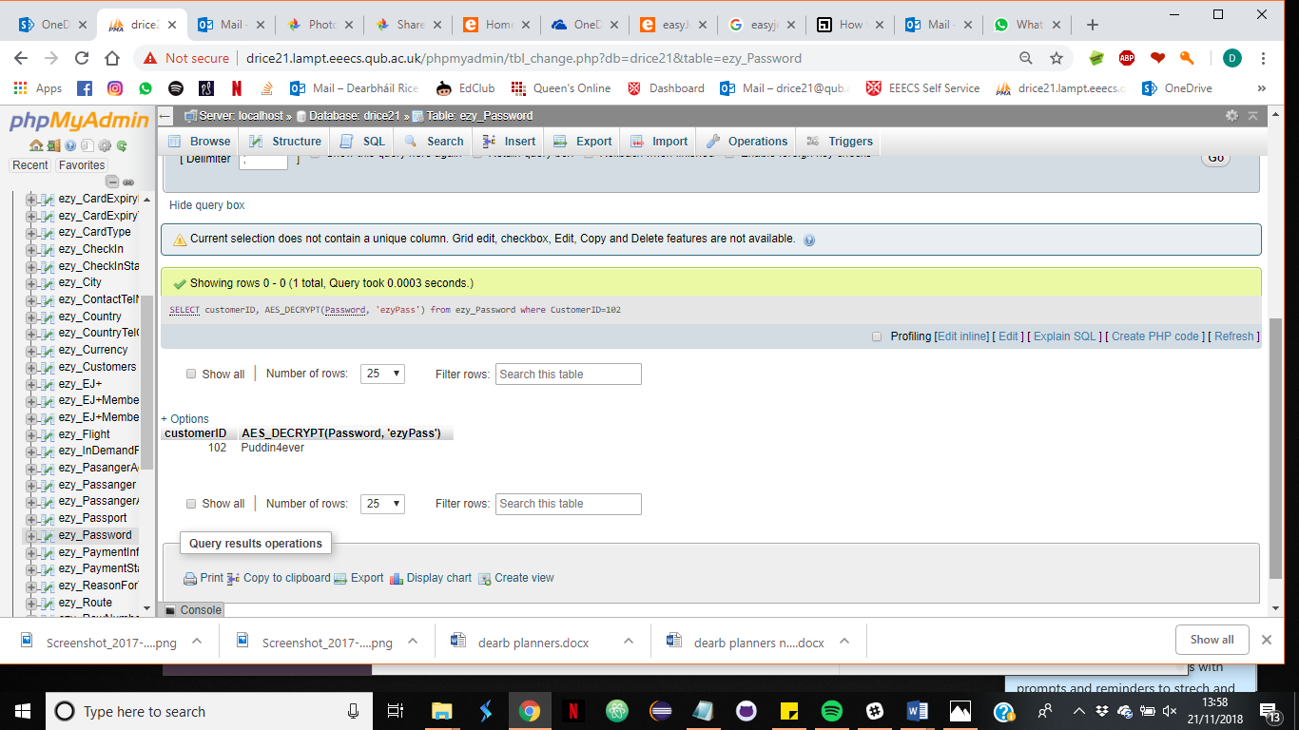

**Step 2. Select destination and preferred dates**

Select out bound departure and arrival airport ( system automatically searches for return flights as well unless one way is selected. And select preferred travel dates.

* 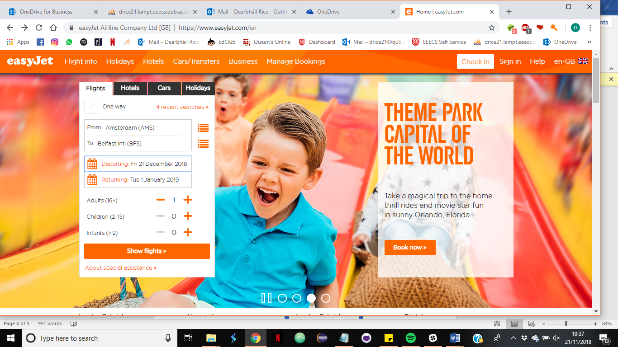On EasyJet UI :
* Corresponding actions on MYSQL:

**Selecting route**

SELECT * FROM ezy_Airport

INNER JOIN ezy_City

On ezy_Airport.CityID= ezy_City.CityID

Inner JOIN ezy_Route

ON ezy_Airport.AirportID = ezy_Route.DepartureAirportID

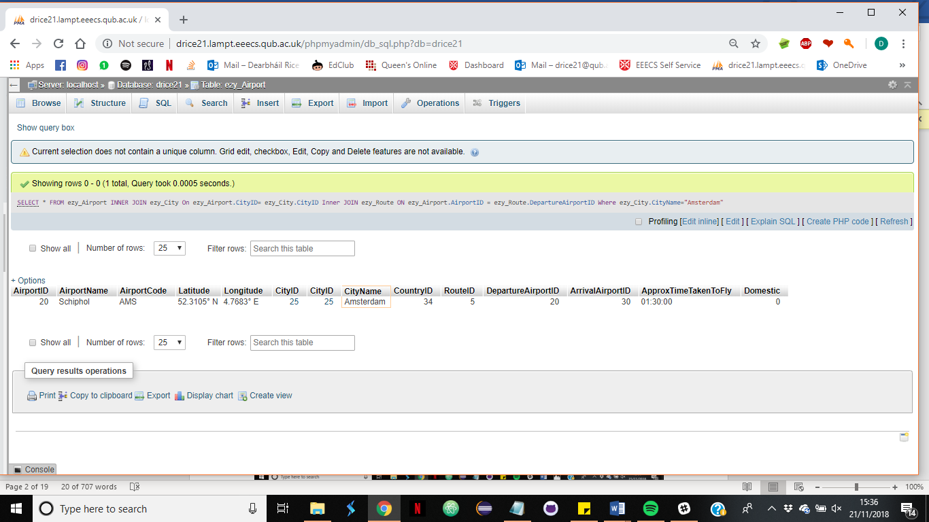Where ezy_City.CityName="Amsterdam" ;

The results indicate that there is one airport in Amsterdam called Schiphol with the AirportID 20 which, for the purpose of demonstration, has a single route flying from it .

A similar query can be written for the return flight

SELECT * FROM ezy_Airport

INNER JOIN ezy_City

On ezy_Airport.CityID= ezy_City.CityID

Inner JOIN ezy_Route

ON ezy_Airport.AirportID = ezy_Route.DepartureAirportID

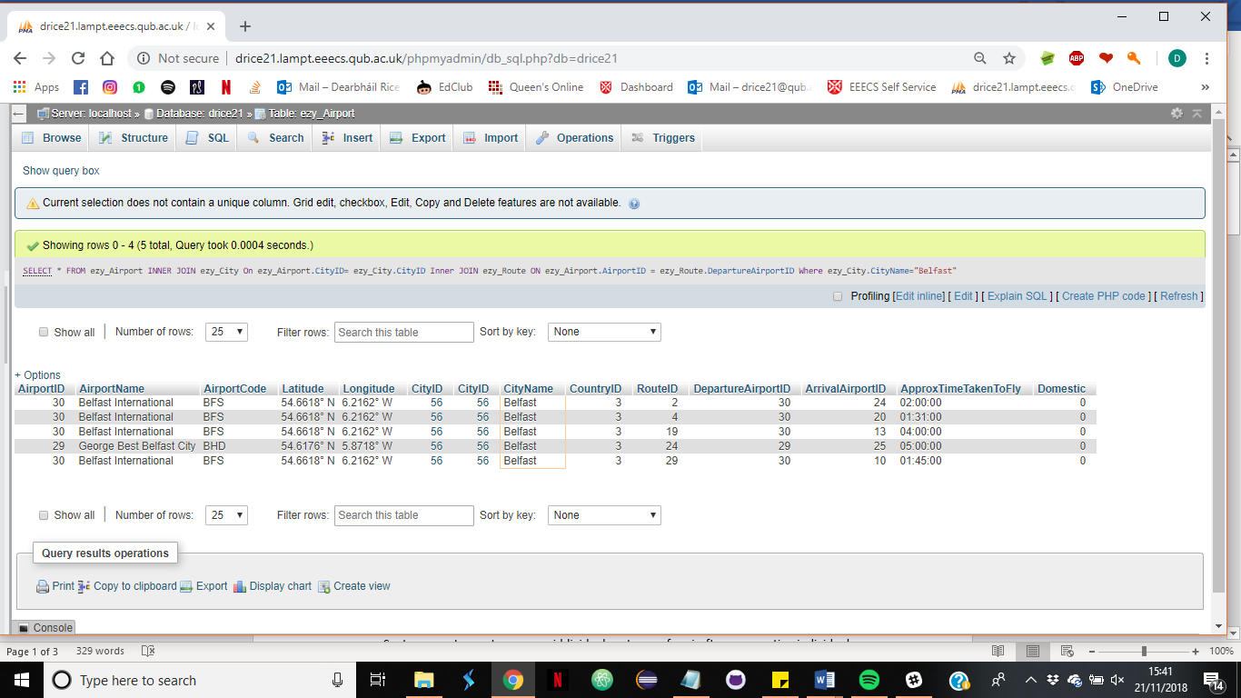Where ezy_City.CityName="Belfast" ;

The above results indicate there are two airports in Belfast, Belfast international with an AirportID of 30 and George Best Belfast city Airport with an AIrportID of 29.

Using the Airport IDs discovered in the above results routes flying between Amsterdam and Belfast can be selected.

Select* From ezy_Route

where (DepartureAirportID = 20 OR DepartureAirportID= 30 OR DepartureAirportID = 29)

AND (ArrivalAirportID=20 OR ArrivalAirportID=30 OR ArrivalAirportID=29);

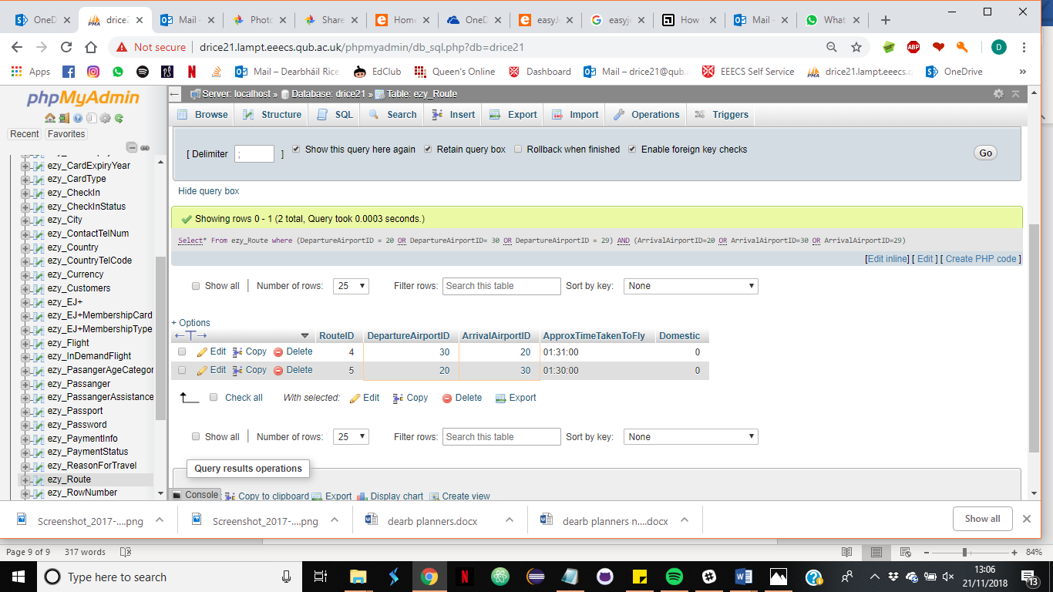

It is now known that route 4 flies from Amsterdam to Belfast and route 5 flies Belfast to Amsterdam from the Foreign keys of DepartureAirportID and ArrivalAirportID.

**Step 3.Flight dates and times**

Select the date and time for outbound and return flights separately.

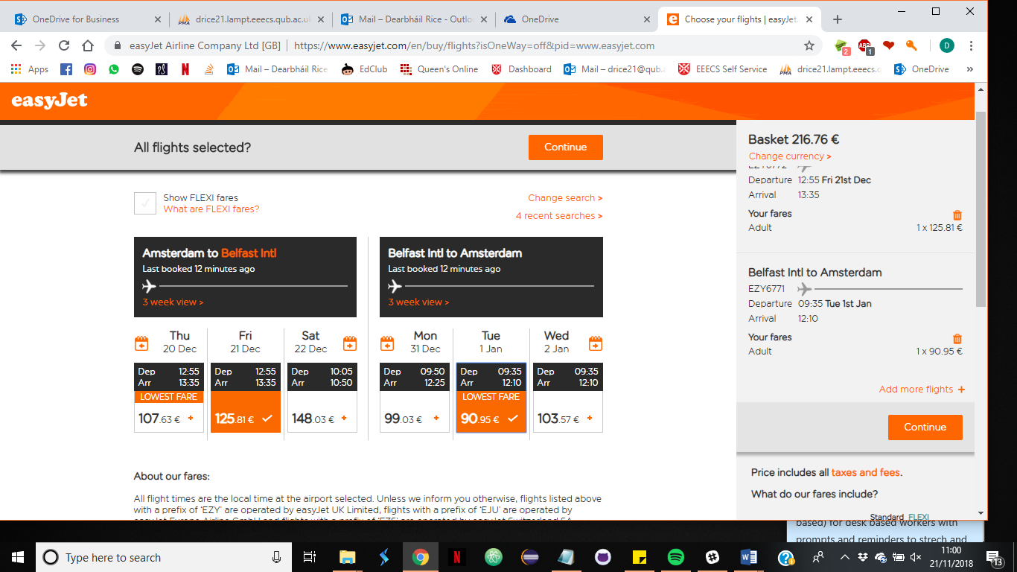On easyJetUI:

* Corresponding actions on MySQL database:

Select * FROM ezy_Schedule

where RouteID = 4 OR RouteID=5 ;

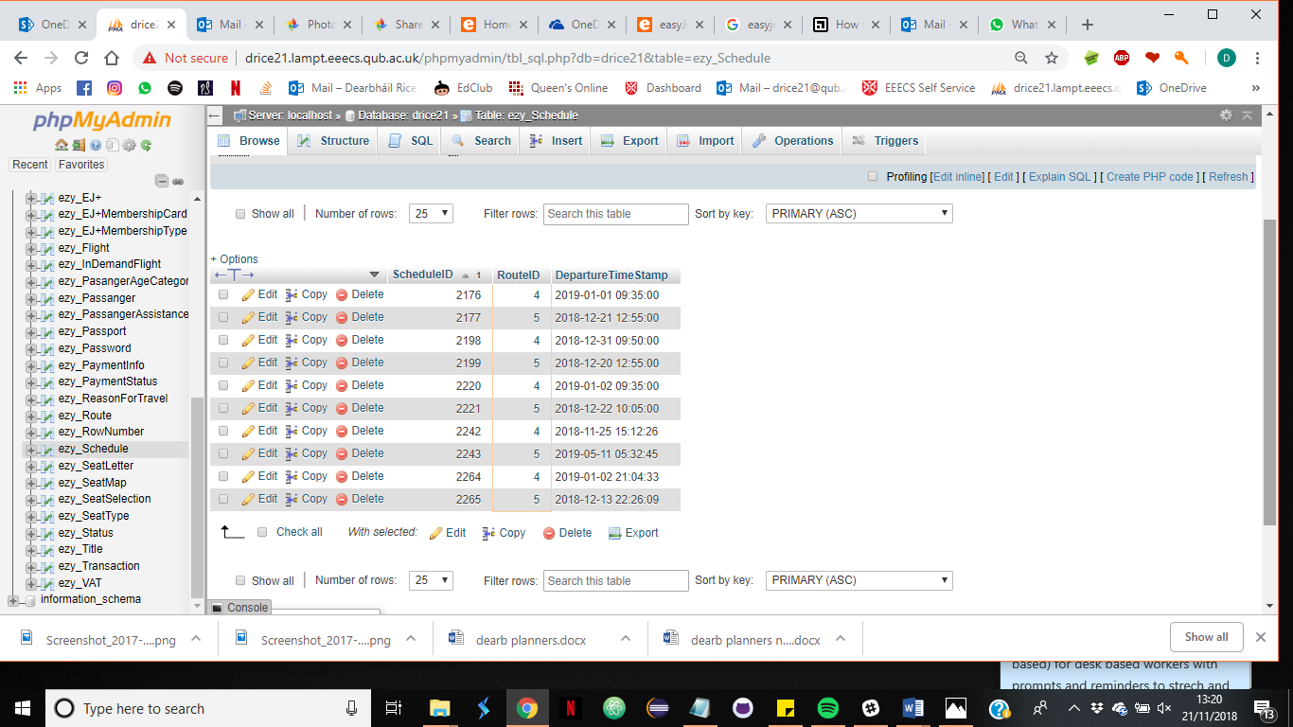

Availible flight dates and times are displayed above.

The customer selects the flights corresponding with ScheduleID 2177 (outbound) and 2176 (Return)

**Step 4. Selecting seats**

The customer wishes to select an “Upfront” seat for out bound and return flight. In this case seat 1A was available and selected for both flights.

* 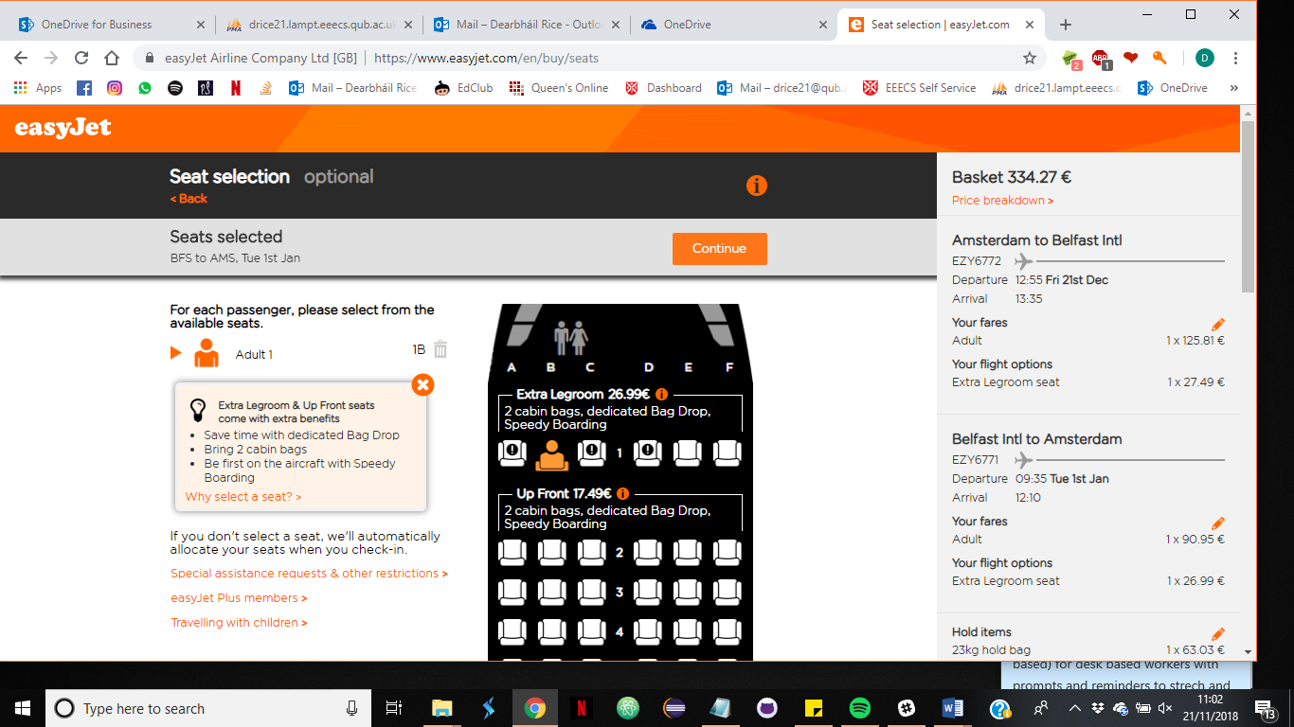Selection on EasyJet UI:
* 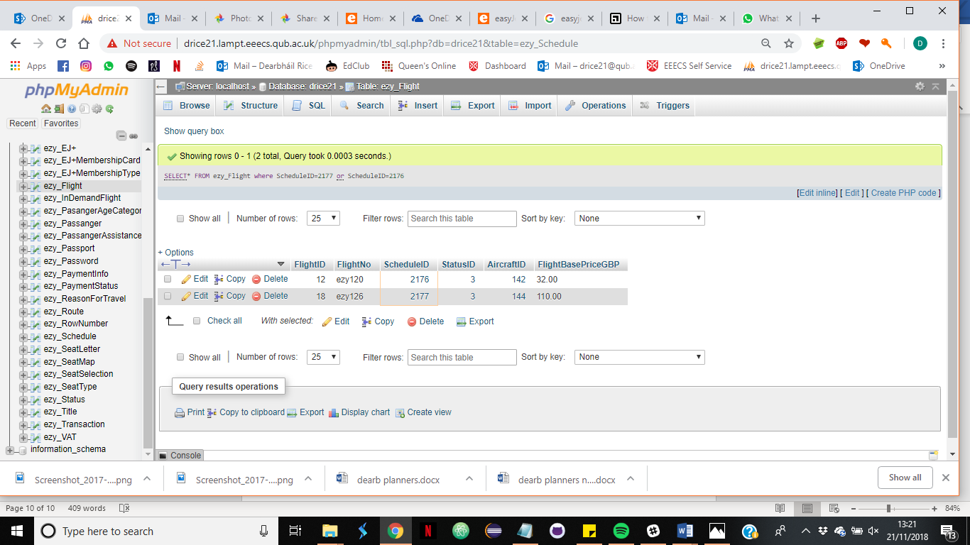corresponding actions in MySQL :

1. Find The flight number
2. Select appropriate seat map for each flight

[SELECT](http://drice21.lampt.eeecs.qub.ac.uk/phpmyadmin/url.php?url=https://dev.mysql.com/doc/refman/5.5/en/select.html)* FROM ezy_Flight

 inner Join ezy_Aircraft

 ON ezy_Flight.AircraftID = ezy_Aircraft.AircraftID

INNER JOIN ezy_SeatMap

ON ezy_Aircraft.AircraftTypeID = ezy_SeatMap.AircraftTypeID

where ezy_Flight.ScheduleID=2177 [OR](http://drice21.lampt.eeecs.qub.ac.uk/phpmyadmin/url.php?url=https://dev.mysql.com/doc/refman/5.5/en/logical-operators.html#operator_or) ezy_Flight.ScheduleID=2176

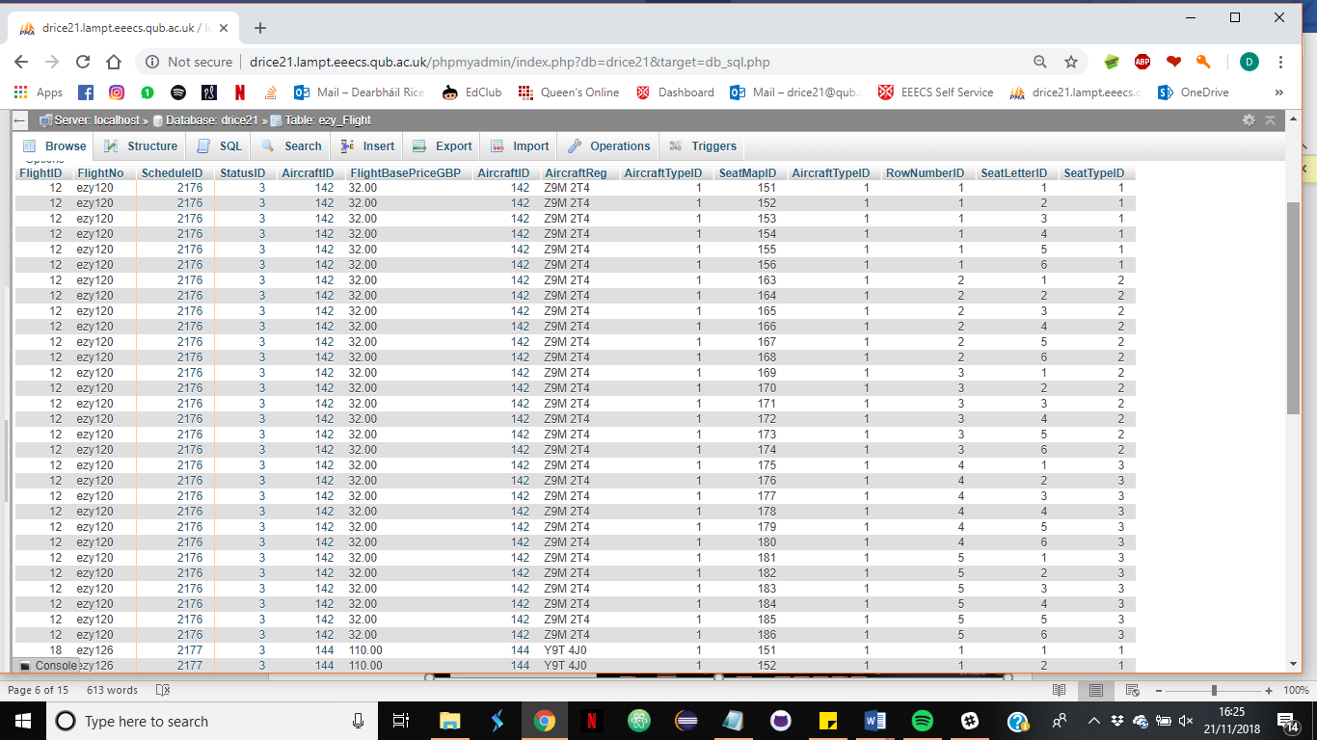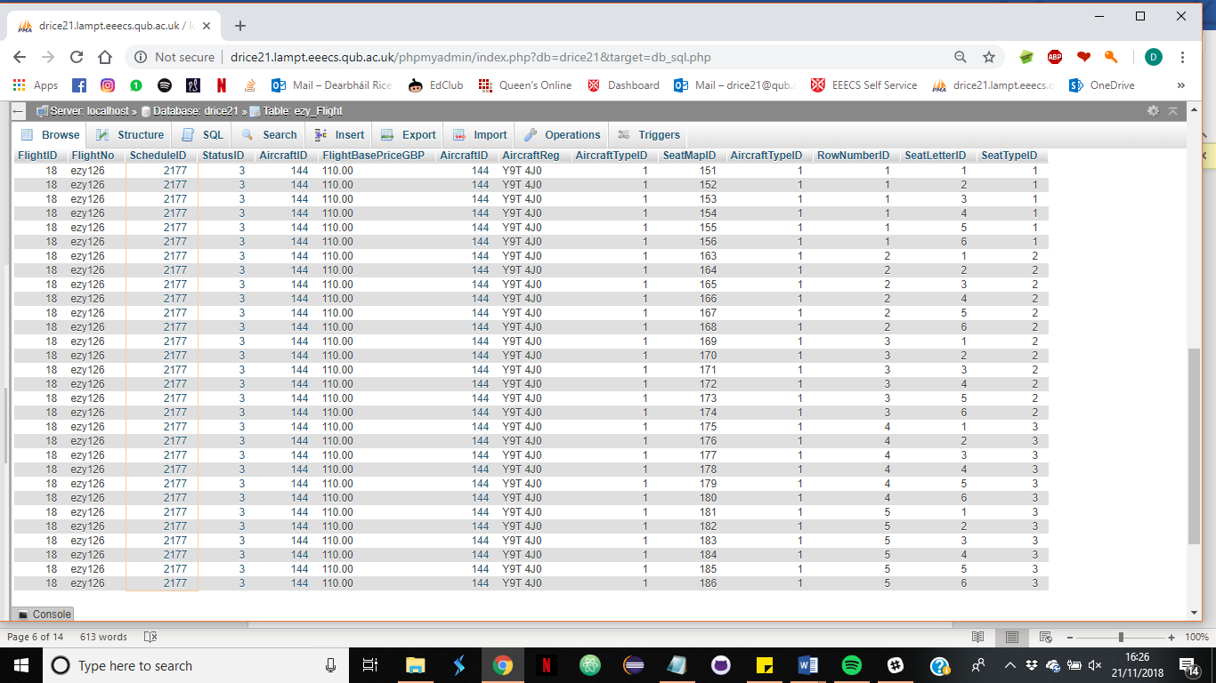

1. Selecting seat 1A

Note a programme would be used to ensure seats already selected are not available on the customer UI for selection.

SELECT* FROM ezy_Flight

inner Join ezy_Aircraft

ON ezy_Flight.AircraftID = ezy_Aircraft.AircraftID

INNER JOIN ezy_SeatMap

ON ezy_Aircraft.AircraftTypeID = ezy_SeatMap.AircraftTypeID

INNER Join ezy_SeatLetter

ON ezy_SeatMap.SeatLetterID=ezy_SeatLetter.SeatLetterID

where (ezy_Flight.ScheduleID=2177 OR ezy_Flight.ScheduleID=2176)And (ezy_SeatMap.RowNumberID= 1) AND (SeatLetter= "A");

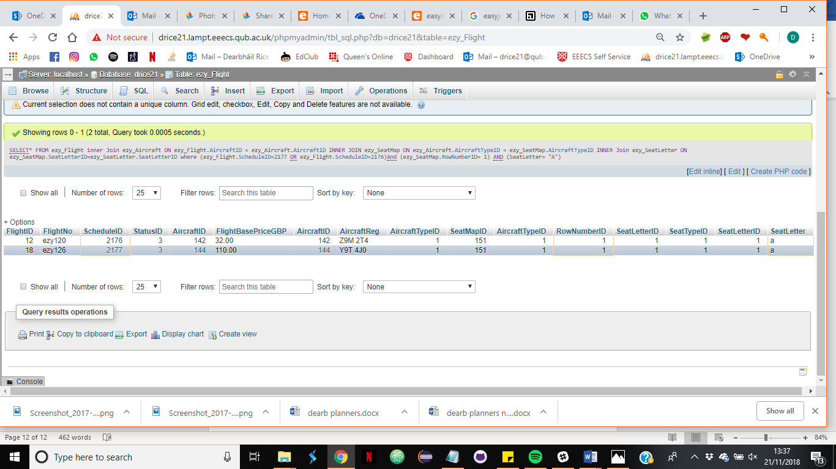At this point a seat has been identified and should be held by a java programme until it is classed as selected when the seat has been connected to a booking ID

* Creating a booking

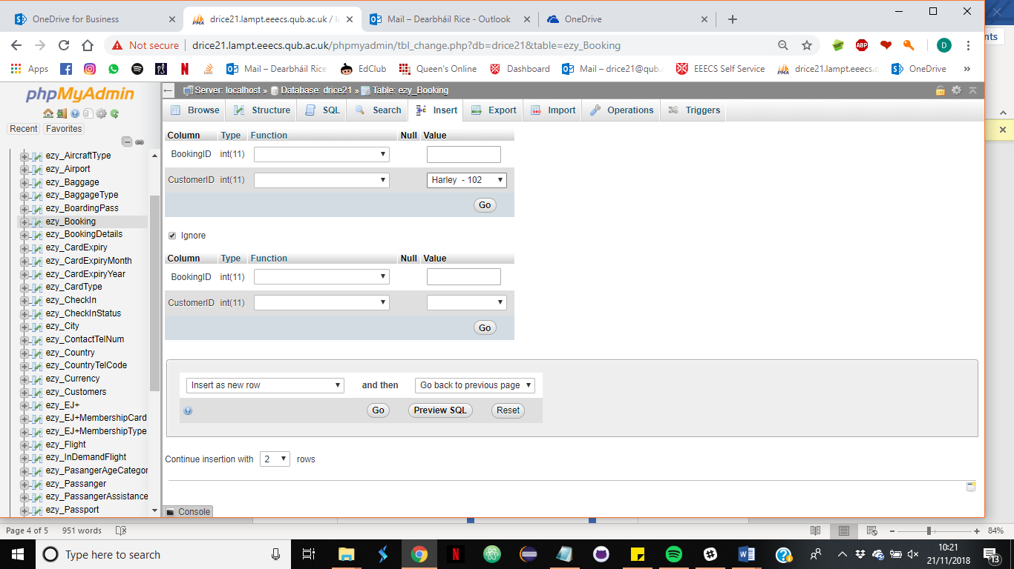A booking is created to hold all the customer selections and allow clear pricing through out the booking process. It is assumed that a java programme would delete any booking that are not completed within an appropriate time frame to prevent unnecessary data being stored in the system.

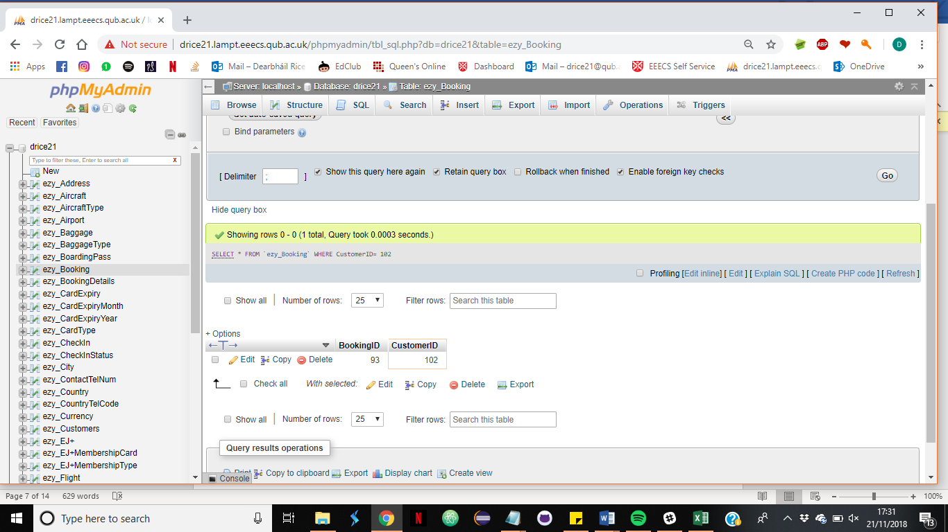SELECT * FROM `ezy_Booking` WHERE CustomerID= 102;

* 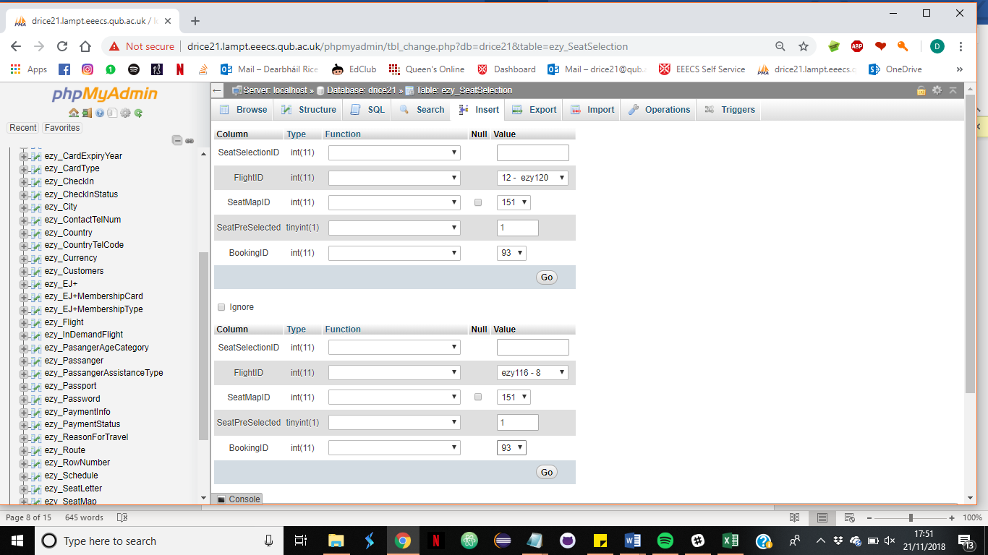Creating Seat selection:

SELECT * FROM `ezy_SeatSelection` WHERE BookingID=93;

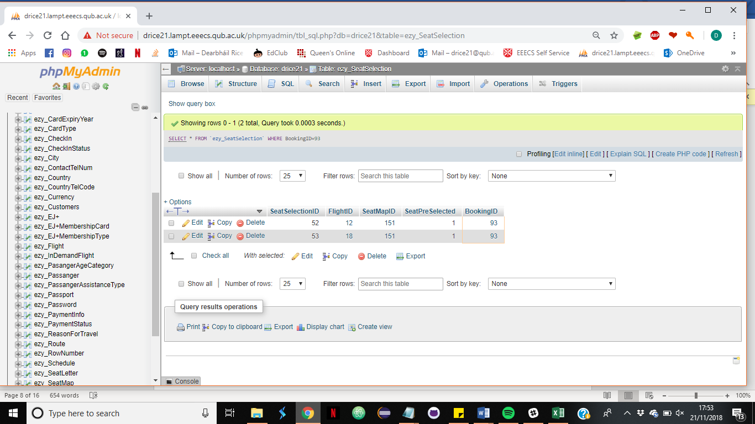

**Step 5. Select Baggage**

* 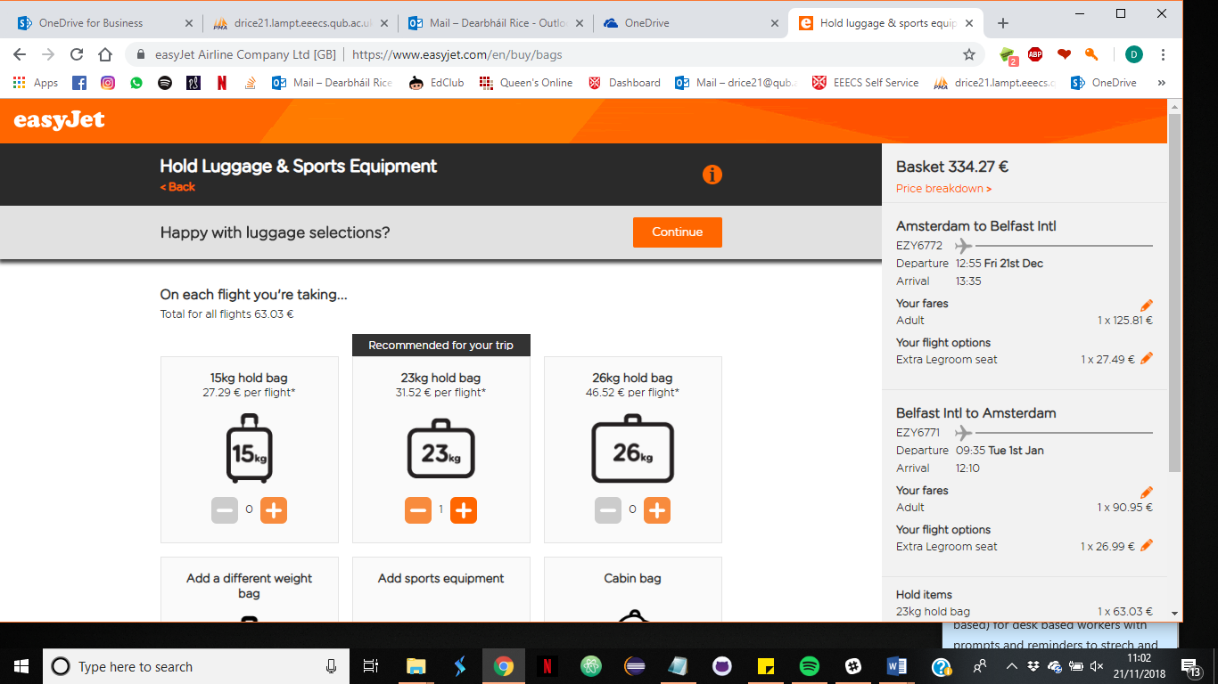Selection on EasyJet UI:
* Corresponding actions in MySQL:

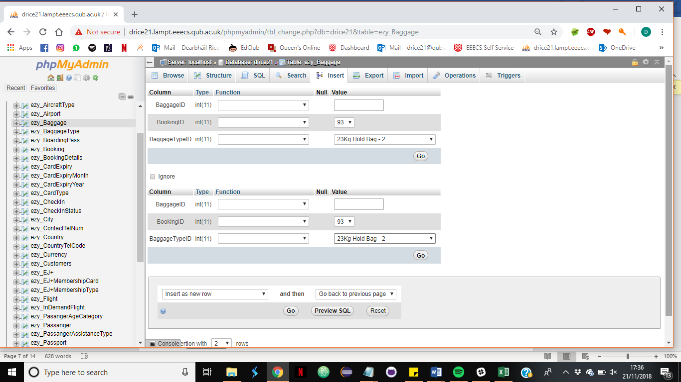

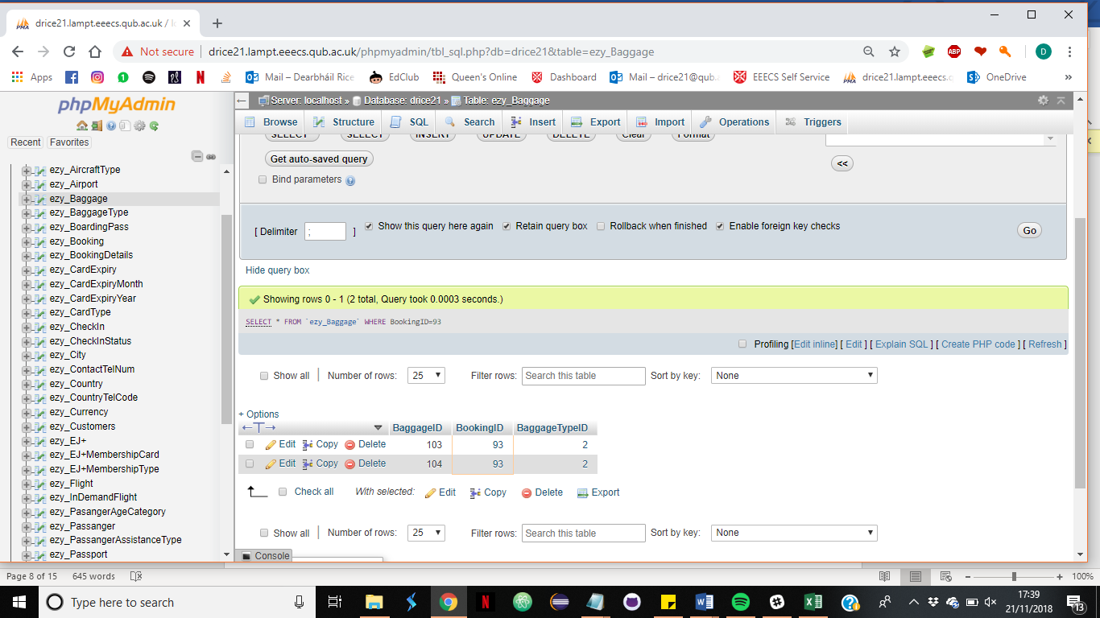SELECT * FROM `ezy_Baggage` WHERE BookingID=93;

**Step 6. Log in**

* On EasyJet UI:

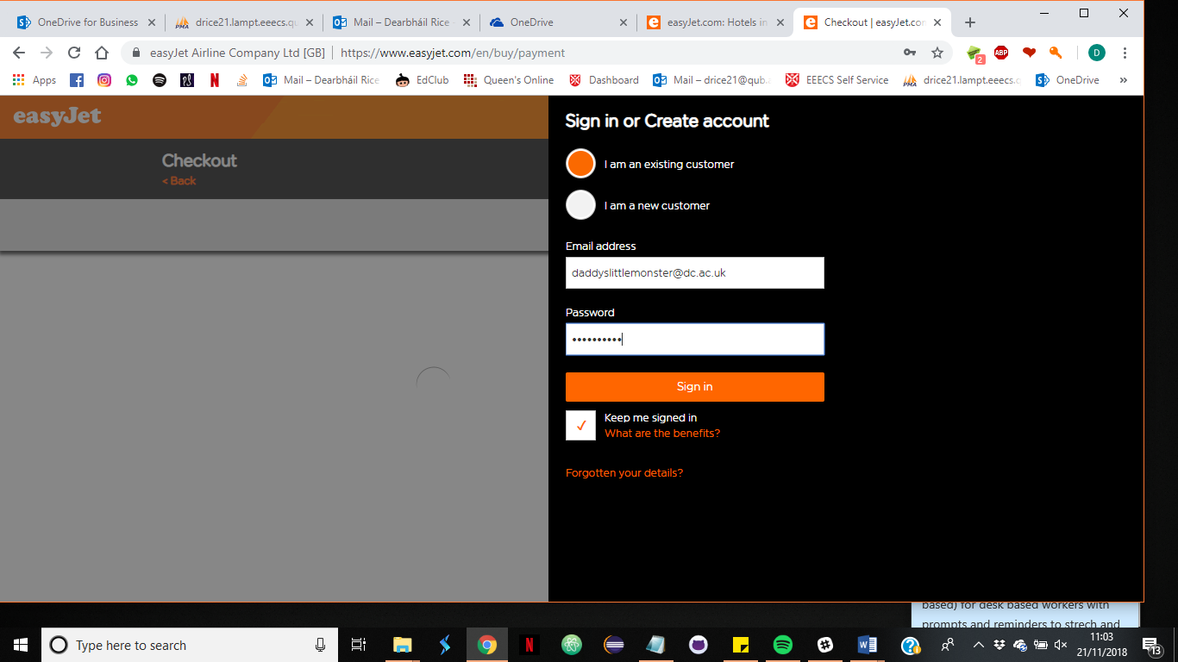

* Corresponding MySQL:

Select * FROM ezy_Customers

Inner JOIN ezy_Password

ON ezy_Customers.CustomerID = ezy_Password.CustomerID

Where ezy_Customers.EmailAddress="daddyslittlemonster@dc.ac.uk";

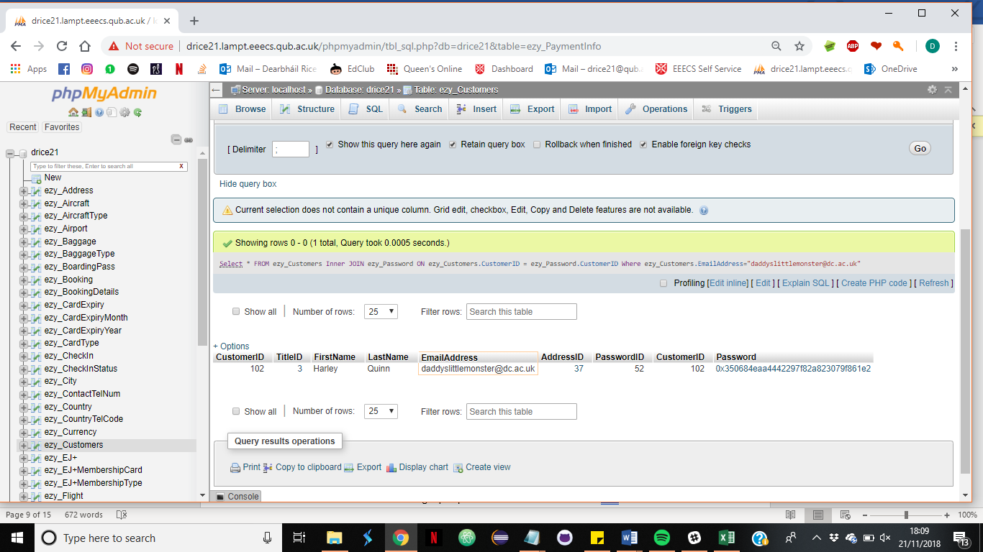

decrypt the password:

SELECT customerID, AES_DECRYPT(Password, 'ezyPass') from ezy_Password

where CustomerID=102;

A java programme would be used to confirm the confirm all login details are correct before allowing successful login.

**Step 7. Passenger Information**

Passengers individual information must be entered passenger assistance types can be selected at this point.

* Data input on EasyJet UI:

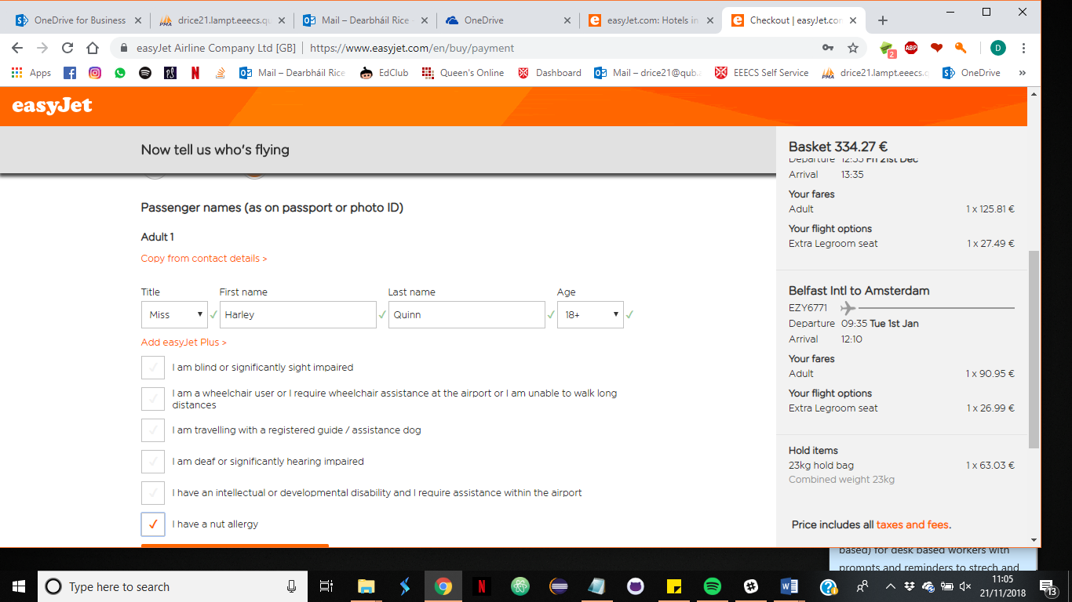

* Corresponding data entry in MySQL

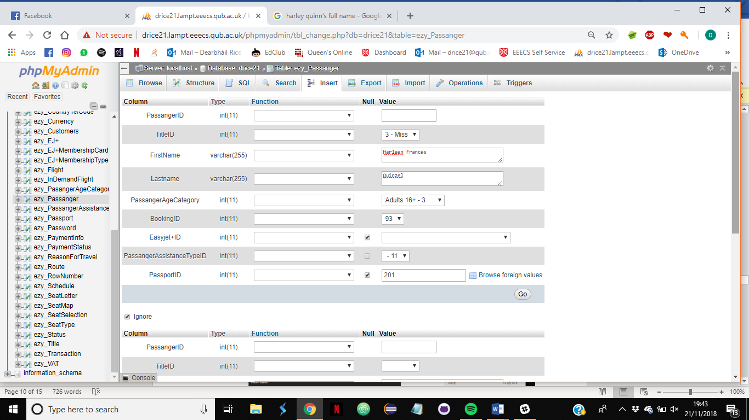

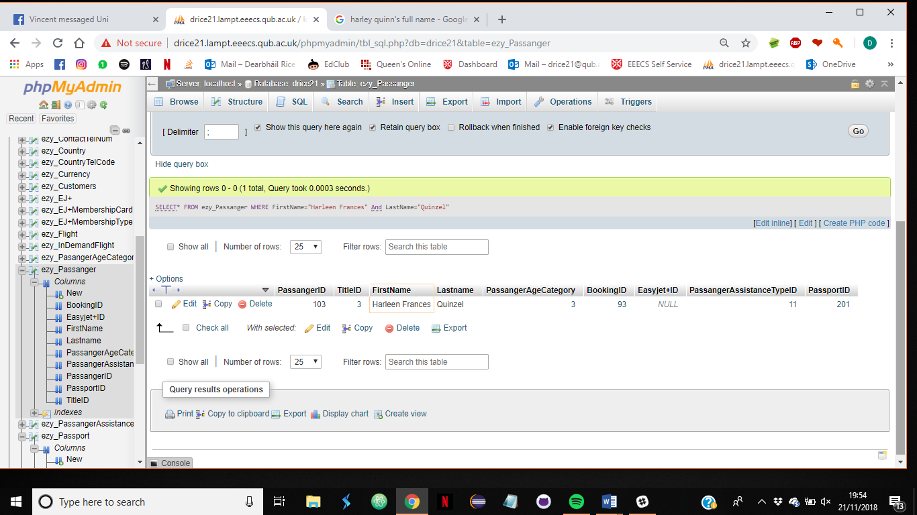SELECT* FROM ezy_Passanger WHERE BookingID=93;

**Step 8. Enter payment information**

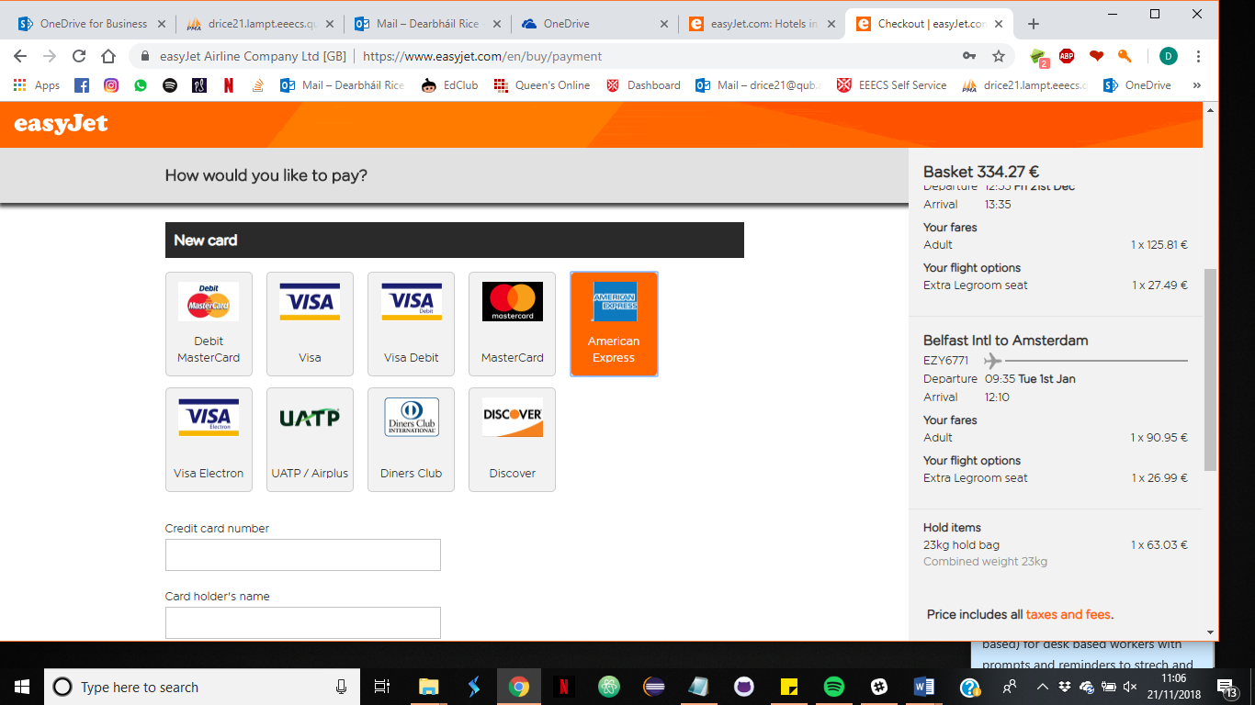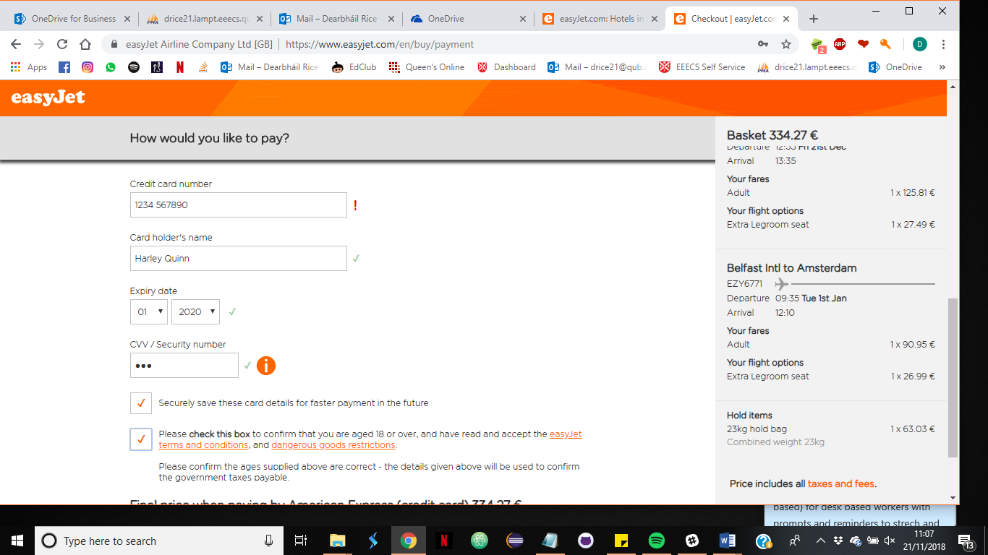-EazyJet UI data input

- corresponding MySQL input

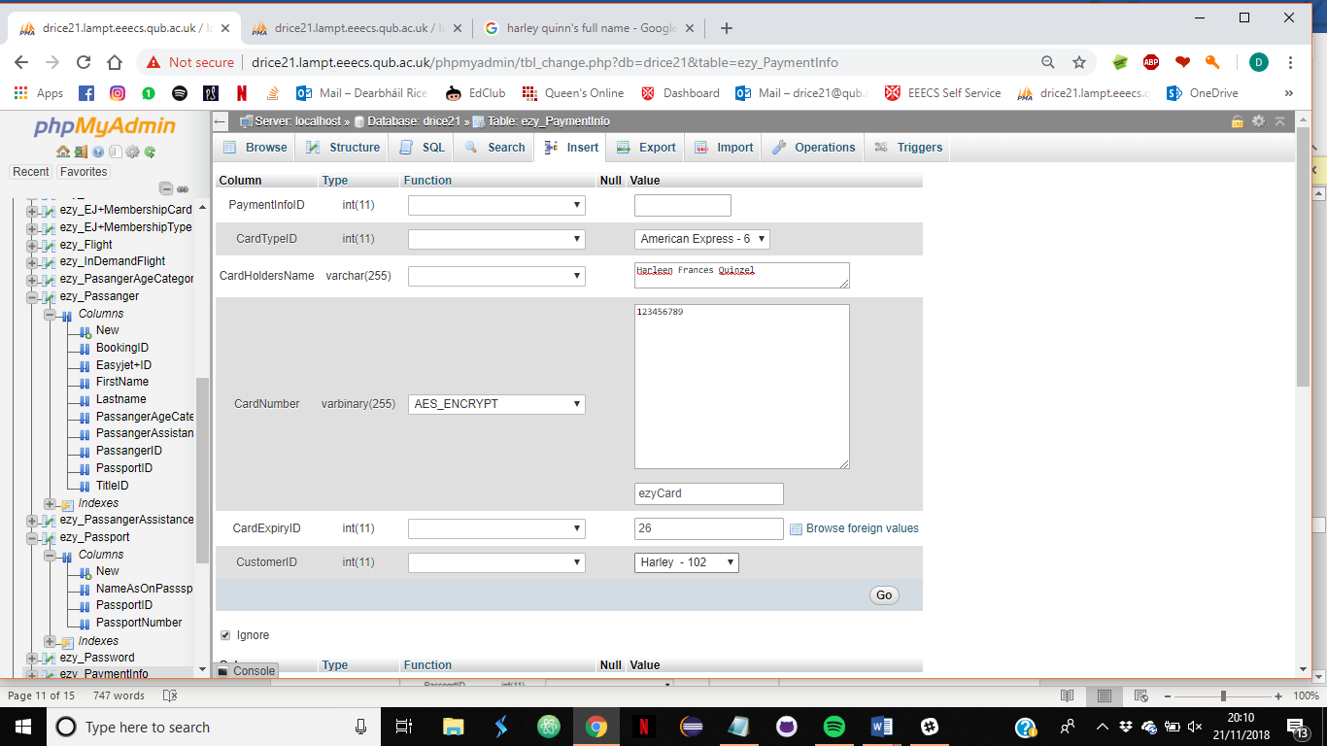

SELECT * FROM `ezy_PaymentInfo` WHERE CustomerID=102;

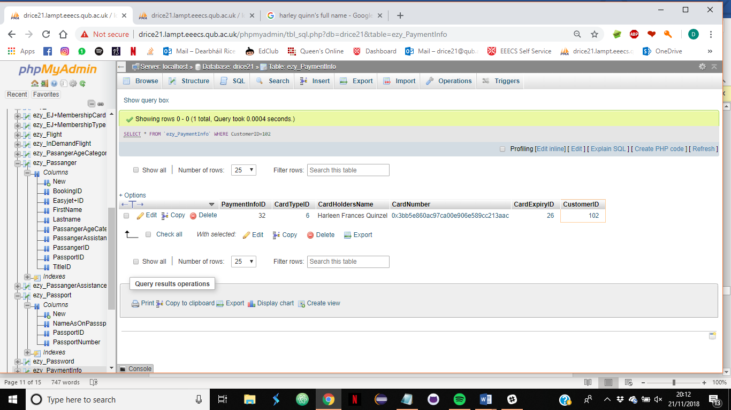

SELECT *, AES_DECRYPT(CardNumber, 'ezyCard') from ezy_PaymentInfo WHERE CustomerID=102;

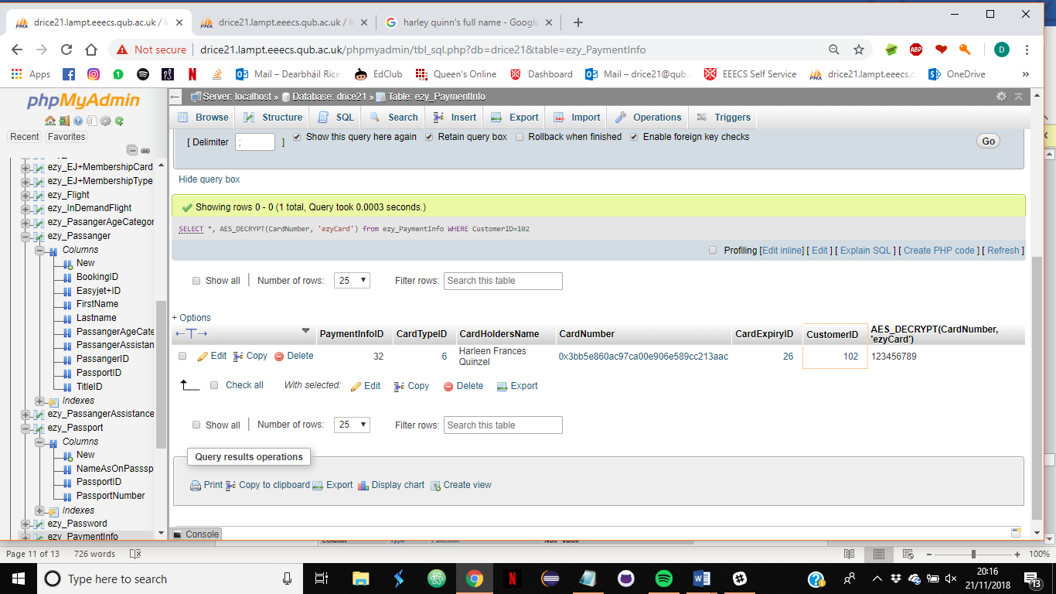

Note the database does not store CSV number to aid data protection and improve security. Note the final flight price must be calculated from the prices stored within the database and a pricing algorithm therefore the database does not independently calculate the final booking price but relies on a java program to enter the total price into the transaction table ( for the purpose of demonstration prices The IndemandFlightPrices table is used as a rudimentary substitute )

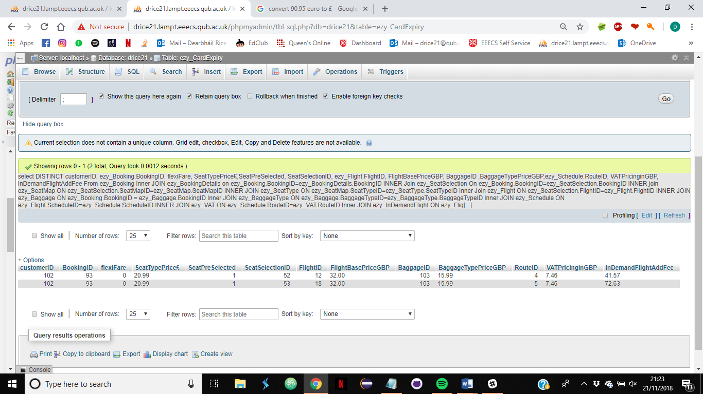

select DISTINCT customerID, ezy_Booking.BookingID, flexiFare, SeatTypePrice£,SeatPreSelected, SeatSelectionID, ezy_Flight.FlightID, FlightBasePriceGBP, BaggageID ,BaggageTypePriceGBP,ezy_Schedule.RouteID, VATPricinginGBP, InDemandFlightAddFee

From ezy_Booking

Inner JOIN ezy_BookingDetails

on ezy_Booking.BookingID=ezy_BookingDetails.BookingID

INNER Join ezy_SeatSelection

On ezy_Booking.BookingID=ezy_SeatSelection.BookingID

INNER join ezy_SeatMap

ON ezy_SeatSelection.SeatMapID=ezy_SeatMap.SeatMapID

INNER JOIN ezy_SeatType

ON ezy_SeatMap.SeatTypeID=ezy_SeatType.SeatTypeID

Inner Join ezy_Flight

ON ezy_SeatSelection.FlightID=ezy_Flight.FlightID

INNER JOIN ezy_Baggage

ON ezy_Booking.BookingID = ezy_Baggage.BookingID

Inner JOIN ezy_BaggageType

ON ezy_Baggage.BaggageTypeID=ezy_BaggageType.BaggageTypeID

Inner JOIN ezy_Schedule

ON ezy_Flight.ScheduleID=ezy_Schedule.ScheduleID

INNER JOIN ezy_VAT

ON ezy_Schedule.RouteID=ezy_VAT.RouteID

Inner JOIN ezy_InDemandFlight

ON ezy_Flight.FlightID=ezy_InDemandFlight.FlightID

where CustomerID=102 ;

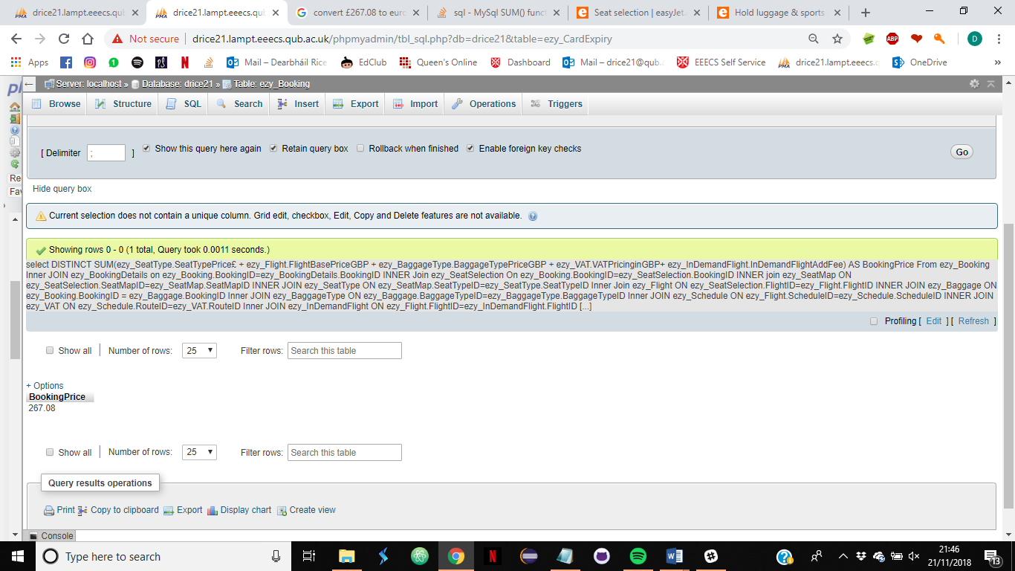

/*Pricing calculation*/

select DISTINCT SUM(ezy_SeatType.SeatTypePrice£ + ezy_Flight.FlightBasePriceGBP + ezy_BaggageType.BaggageTypePriceGBP + ezy_VAT.VATPricinginGBP+ ezy_InDemandFlight.InDemandFlightAddFee) AS BookingPrice

From ezy_Booking

Inner JOIN ezy_BookingDetails

on ezy_Booking.BookingID=ezy_BookingDetails.BookingID

INNER Join ezy_SeatSelection

On ezy_Booking.BookingID=ezy_SeatSelection.BookingID

INNER join ezy_SeatMap

ON ezy_SeatSelection.SeatMapID=ezy_SeatMap.SeatMapID

INNER JOIN ezy_SeatType

ON ezy_SeatMap.SeatTypeID=ezy_SeatType.SeatTypeID

Inner Join ezy_Flight

ON ezy_SeatSelection.FlightID=ezy_Flight.FlightID

INNER JOIN ezy_Baggage

ON ezy_Booking.BookingID = ezy_Baggage.BookingID

Inner JOIN ezy_BaggageType

ON ezy_Baggage.BaggageTypeID=ezy_BaggageType.BaggageTypeID

Inner JOIN ezy_Schedule

ON ezy_Flight.ScheduleID=ezy_Schedule.ScheduleID

INNER JOIN ezy_VAT

ON ezy_Schedule.RouteID=ezy_VAT.RouteID

Inner JOIN ezy_InDemandFlight

ON ezy_Flight.FlightID=ezy_InDemandFlight.FlightID

where CustomerID=102 ;

SELECT * FROM `ezy_Transaction` WHERE BookingID=93;

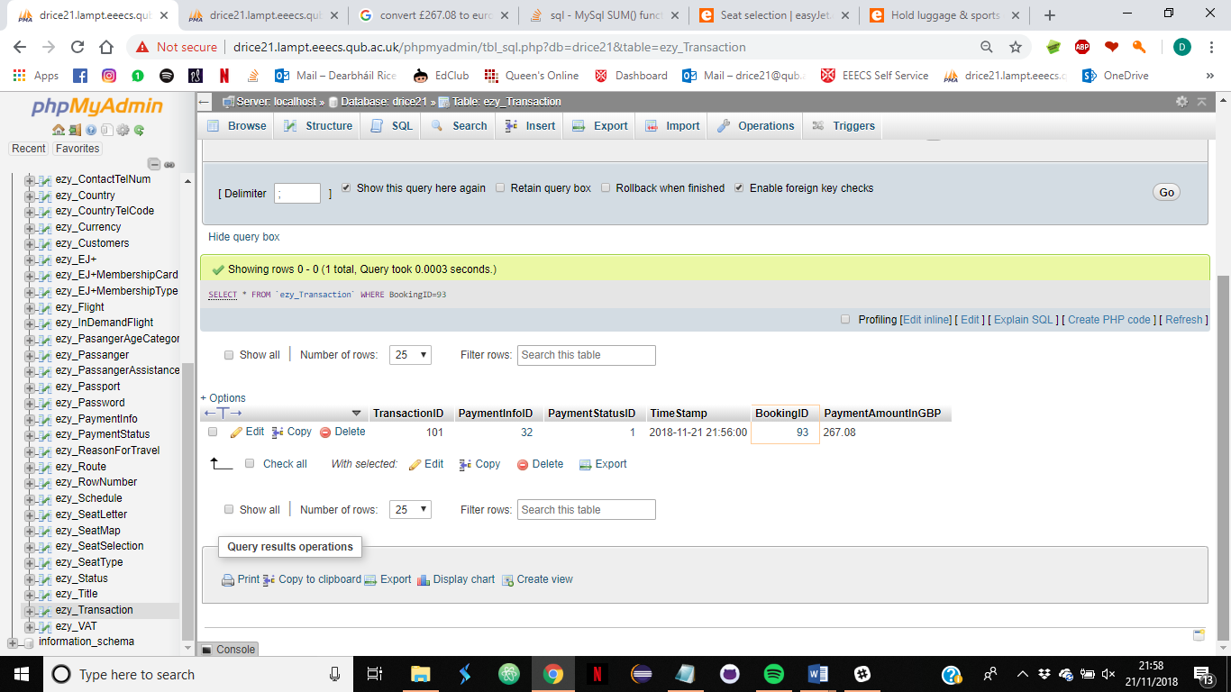

At this point a java program would check the payment status and if the status is complete (ID 1 ) the program would email customers their booking confirmation including their booking reference ( in this case the BookingID) Customers are then able to use their booking reference to check In to their flight through the EasyJet UI

**Step 9. Checkin**

Log in through checkin portal and use booking reference to checkin

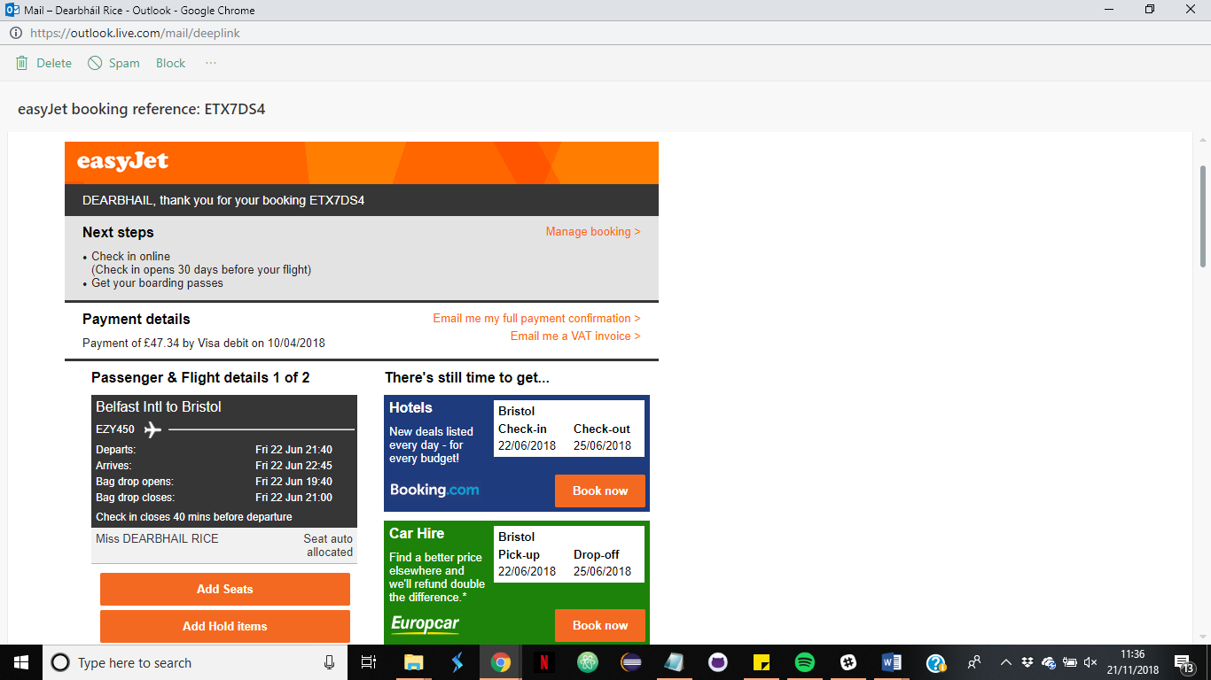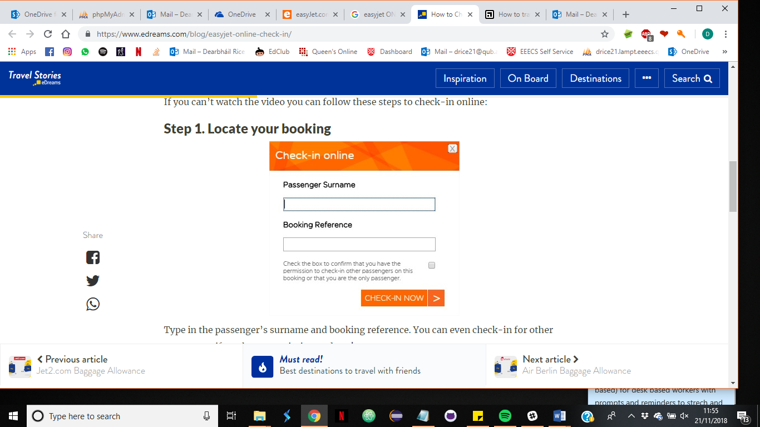

On Checkin passengers traveling on non-domestic/international flights are prompted to input passport information

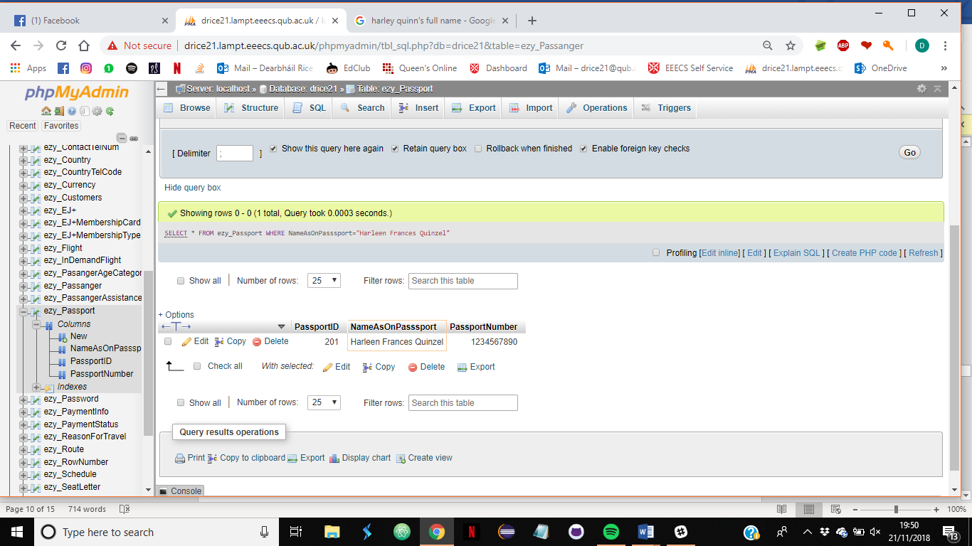SELECT * FROM ezy_Passport WHERE NameAsOnPasssport="Harleen Frances Quinzel";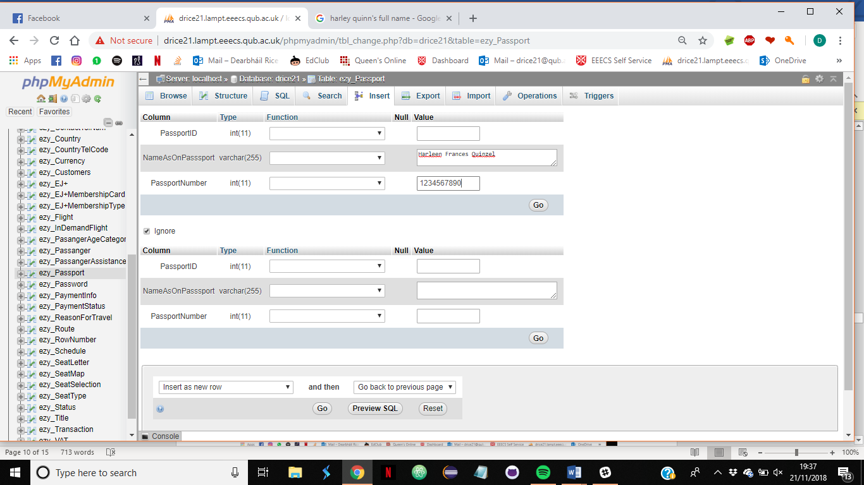

**Step 10. Boarding pass**

On successful completion of check-in boarding passes are created (examples of boarding passes)

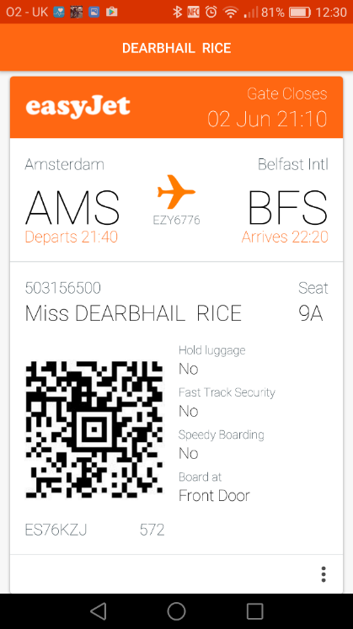 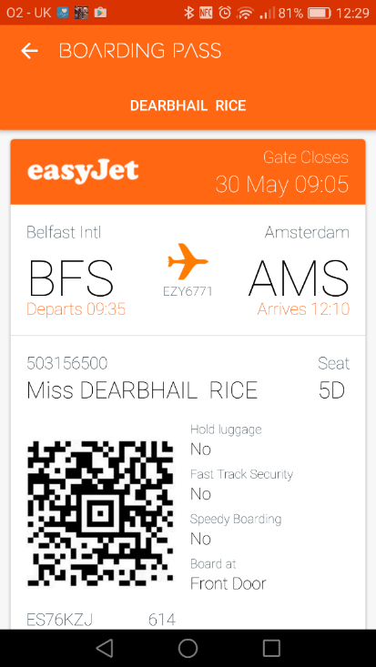

MySQL Results for boarding pass query

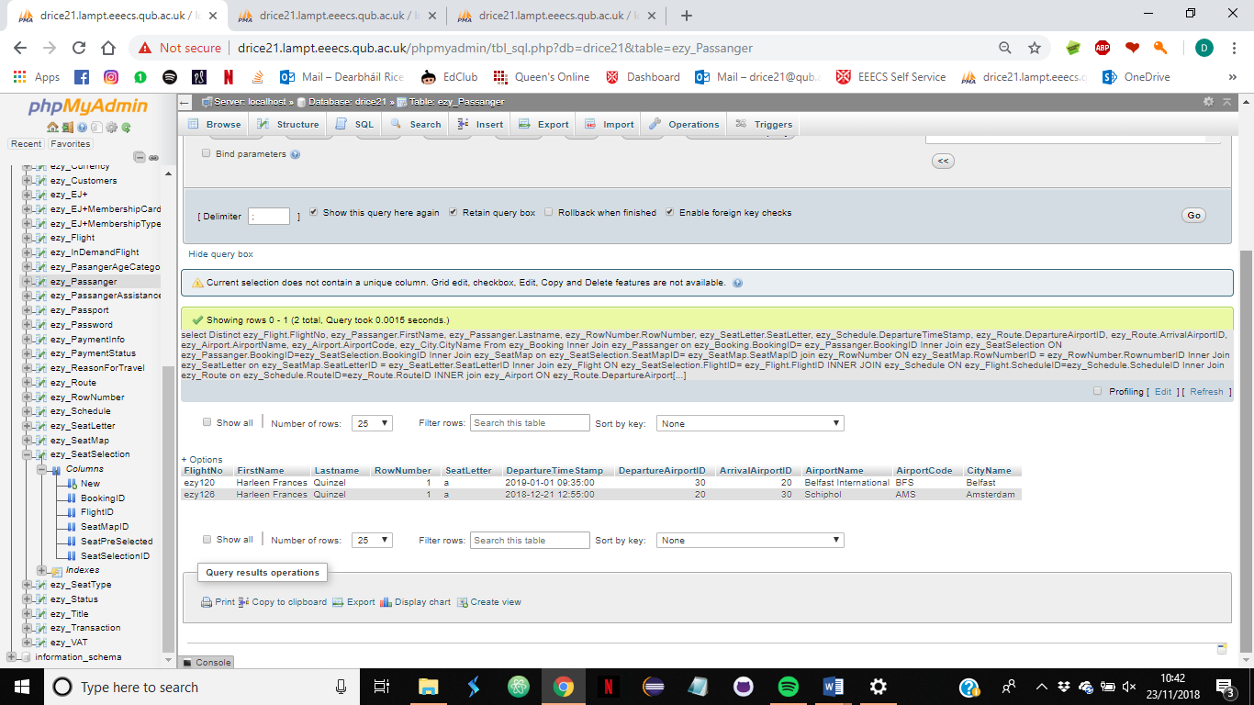

MySQL query to develop boarding Pass

select Distinct ezy_Flight.FlightNo, ezy_Passanger.FirstName, ezy_Passanger.Lastname, ezy_RowNumber.RowNumber, ezy_SeatLetter.SeatLetter, ezy_Schedule.DepartureTimeStamp, ezy_Route.DepartureAirportID, ezy_Route.ArrivalAirportID, ezy_Airport.AirportName, ezy_Airport.AirportCode, ezy_City.CityName

From ezy_Booking

Inner Join ezy_Passanger

on ezy_Booking.BookingID= ezy_Passanger.BookingID

Inner Join ezy_SeatSelection

ON ezy_Passanger.BookingID=ezy_SeatSelection.BookingID

Inner Join ezy_SeatMap

on ezy_SeatSelection.SeatMapID= ezy_SeatMap.SeatMapID

join ezy_RowNumber

ON ezy_SeatMap.RowNumberID = ezy_RowNumber.RownumberID

Inner Join ezy_SeatLetter on ezy_SeatMap.SeatLetterID = ezy_SeatLetter.SeatLetterID

Inner Join ezy_Flight

ON ezy_SeatSelection.FlightID= ezy_Flight.FlightID

INNER JOIN ezy_Schedule

ON ezy_Flight.ScheduleID=ezy_Schedule.ScheduleID

Inner Join ezy_Route

on ezy_Schedule.RouteID=ezy_Route.RouteID

INNER join ezy_Airport

ON ezy_Route.DepartureAirportID = ezy_Airport.AirportID

Inner Join ezy_City

ON ezy_Airport.CityID=ezy_City.CityID

where ezy_Booking.BookingID= 93

ORDER BY `ezy_SeatSelection`.`SeatSelectionID` ASC